ST-4 SUMMARY

ST-4 Test Stats | #
Test cases planned for this sprint | 27
Test cases COMPLETED (without errors) | 19 | WHICH FR? | FR 1 SUCCESSFUL  FR 1.1 SUCCESSFUL  FR 1.2 SUCCESSFUL  FR 2 SUCCESSFUL  FR 2.1 SUCCESSFUL  FR 2.4 SUCCESSFUL  FR 3.2 SUCCESSFUL  FR 3.3 SUCCESSFUL  FR 3.4 SUCCESSFUL  FR 4.3 SUCCESSFUL  FR 5.1 SUCCESSFUL  FR 5.2 SUCCESSFUL  FR 5.3 SUCCESSFUL  FR 9 SUCCESSFUL  FR 10 SUCCESSFUL  FR 10.1 SUCCESSFUL  FR 10.2 SUCCESSFUL  FR 10.3 SUCCESSFUL  FR 13 SUCCESSFUL
Test cases NOT COMPLETED | 8 | WHY? | FR 1.3 PARTIALLY SUCCESSFUL: Student- most recent worklog was not on the top; Instructor- SUCCESSFUL  FR 2.5 UNSUCCESSFUL: No error message, only no submission message  FR 3.1 UNSUCCESSFUL: Due date on notification page is incorrect, one of the worklogs is wrong  FR 6 UNSUCCESSFUL: No error message for data retrieved. Incorrect worklog submission status  FR 8.1 UNSUCCESSFUL: No “loading” message when refreshed  FR 8.2 UNSUCCESSFUL: No error message  FR 9.1 PARTIALLY SUCCESSFUL: Notification page had worklog submission but wrong date and time.  FR 12.1 UNSUCCESSFUL: Cannot search by student name, only email
DEFECTS found | 3 | STATUS: | ST4_Defect 1: Open  ST4_Defect 2: Open  ST4_Defect 3: Open

FR 1, 1.1, 1.2, 1.3

STP Test Case # ST-4

Requirement tested: FR 1
Description: The system shall display a home page based on the authenticated user’s role.
Build: v0.2.0_20260325
Determination: SUCCESSFUL

Setup:
Open Safari browser on Mac OS
Navigate to front-facing Moxie server (http://moxie.cs.oswego.edu:7000/)
Execute test

Execution:
- Navigate to the login page.
- Enter valid user credentials.
- Submit login request.
- Wait for authentication to complete.
- Verify that the home page displayed matches the user’s assigned role.

Expected Result:
- When logged in as student
  - Full name of the user.

- When logged in as an instructor
  - **not yet implemented**
What to expect : Distinct homepage

Actual Result:

- When logged in as student
  - Full name of the user visible on the homepage center.

Screenshot -
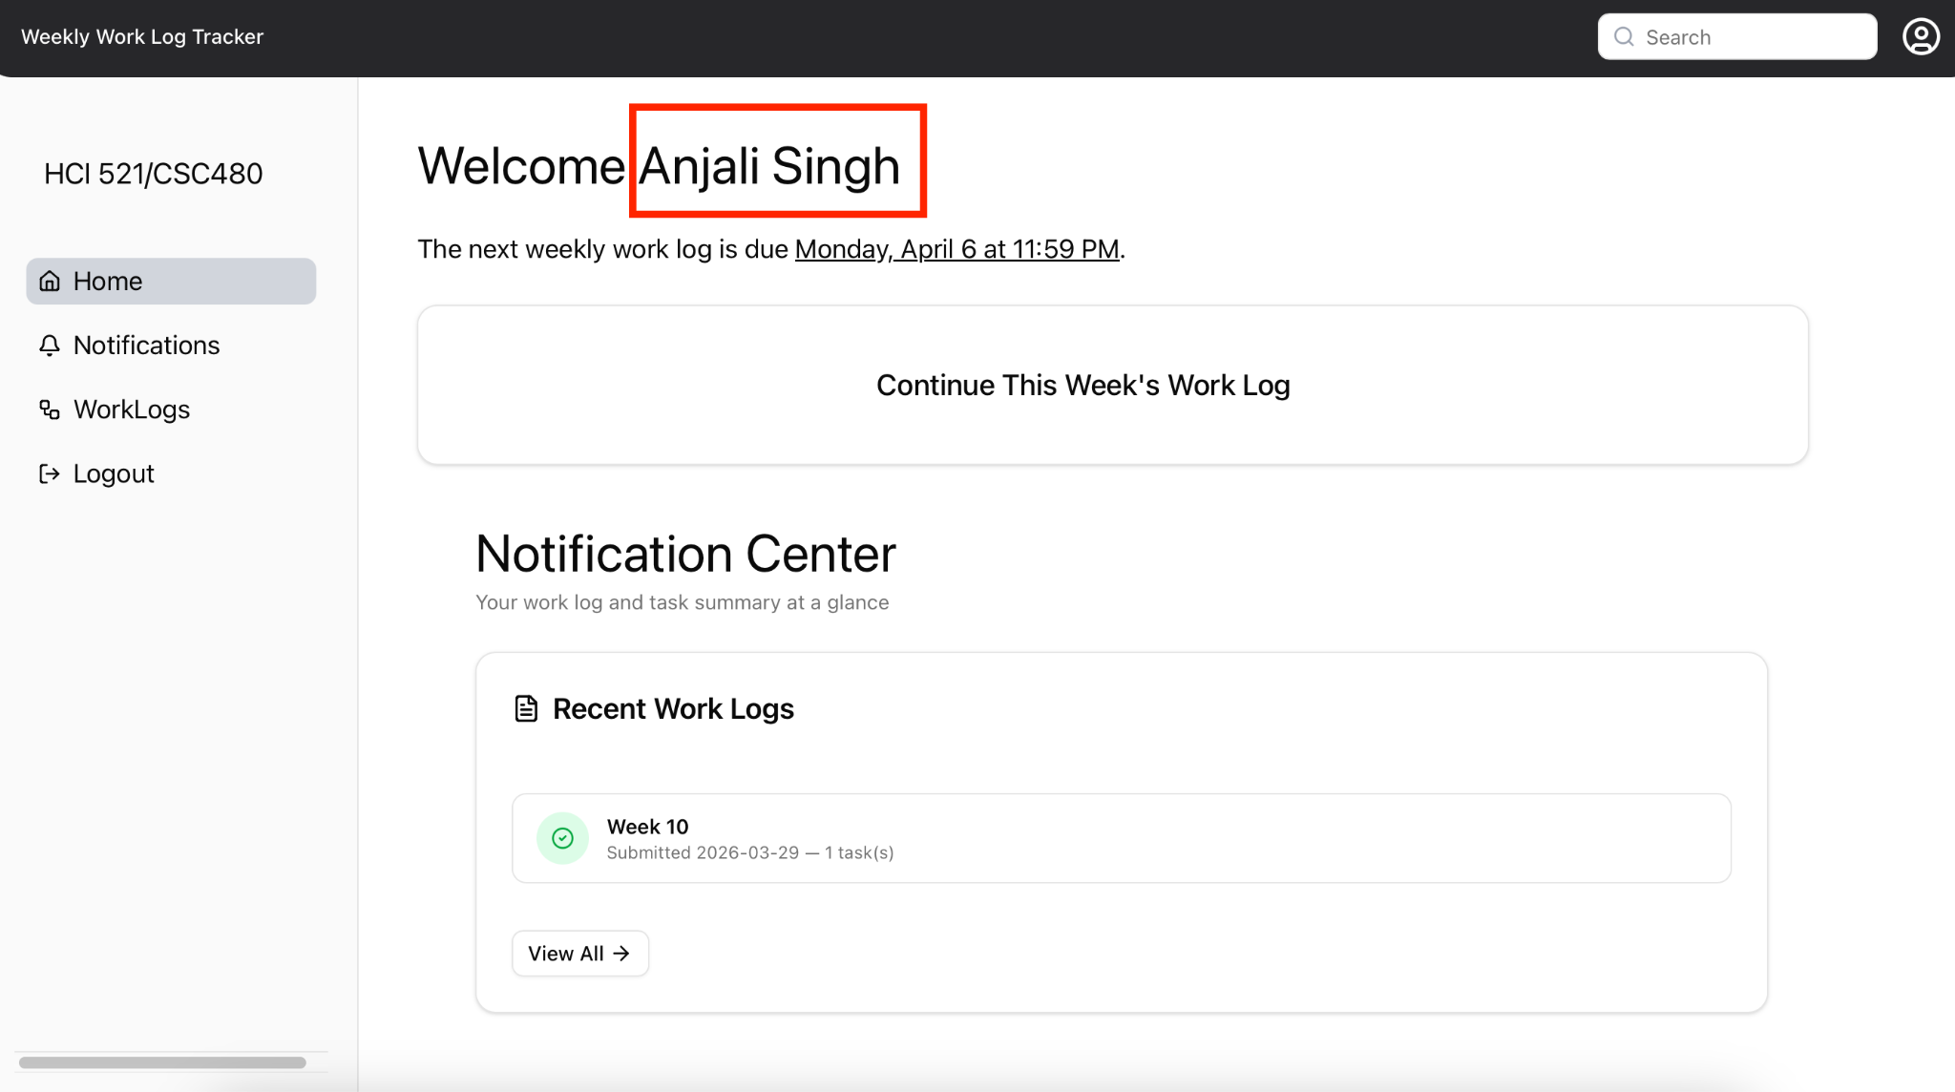

Requirement tested: FR 1.1
Description: The system shall validate the user’s authentication token before determining the user role.
Build: v0.2.0_20260325
Determination: SUCCESSFUL

Setup:
- Open Safari browser on Mac OS
- Navigate to front-facing Moxie server (http://moxie.cs.oswego.edu:7000/)
- Execute test

Execution:
- Log in with valid student id
- Capture the user name mentioned on the home page

Expected Result:
“Currently there is no way to see the validation process in the frontend. Seeing users name on the homepage is a byproduct of validating token.”
What to expect : Full name of the user

Actual Result:
- When logged in w my school id / student :
  - Got logged in
  - Could see the student’s homepage
  - User full name present on the homepage

Screenshot:


Requirement tested: FR 1.2
Description: The system shall extract the user role from the validated authentication token.
Build: v0.2.0_20260325
Determination: SUCCESSFUL

Setup:
- Open Safari browser on Mac OS
- Navigate to front-facing Moxie server (http://moxie.cs.oswego.edu:7000/)
- Execute test

Execution:
- Log in with valid credentials.
- Login using a student id.
- Login using instructor id
- Observe the homepage each time.

Expected Result:
• Login is successful and shows student page when using student token
• Login is successful and shows instructor page when using instructor token
What to expect : Distinct homepage with different tokens/id

Actual Result:
- When logged in w my school id / student :
  - Got logged in
  - Could see the student’s homepage

Screenshot - 

- When logged in w my personal id / instructor :
  - Got logged in
  - Could see the instructor's homepage

Screenshot -
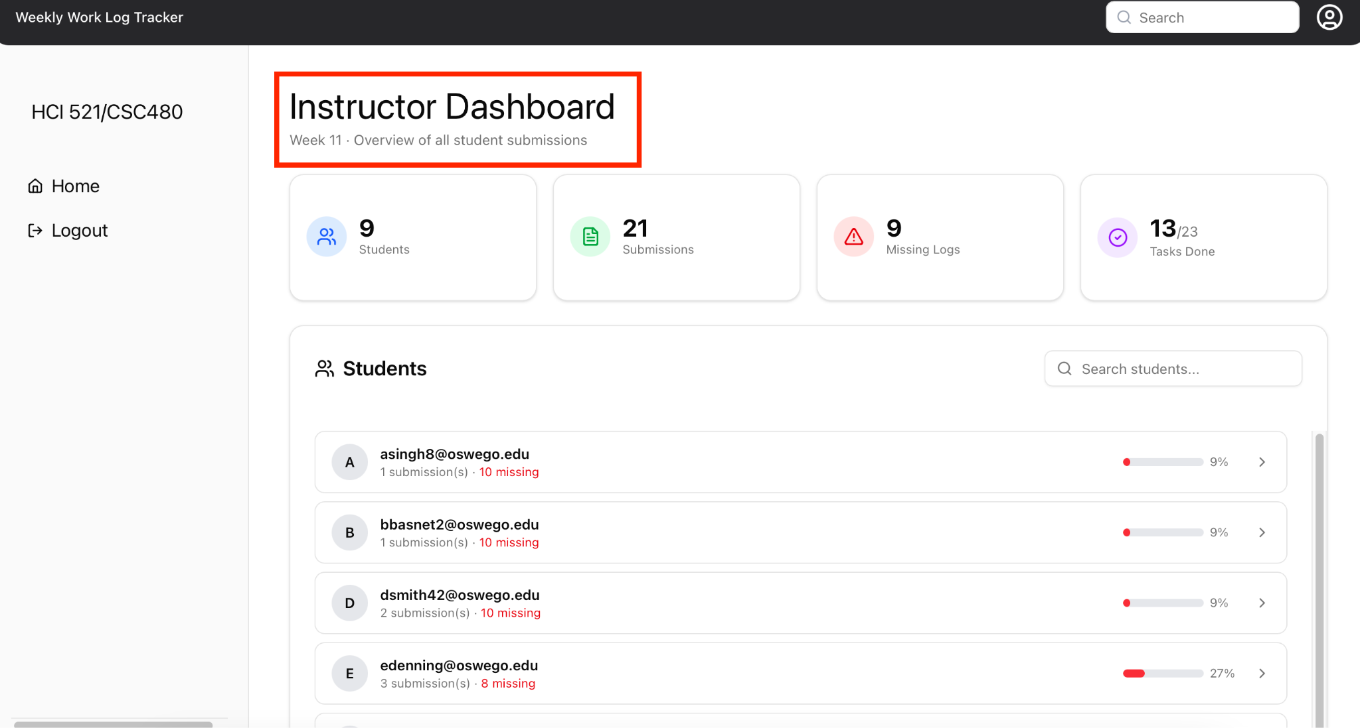

Requirement tested: FR 1.3
Description: The system shall retrieve role-specific home page data based on the extracted role.
Build: v0.2.0_20260325
Determination: PARTIALLY SUCCESSFUL

Setup:

Open Safari browser on Mac OS
Navigate to front-facing Moxie server (http://moxie.cs.oswego.edu:7000/)
Execute test

Execution:
- Log in as a user with a specific role .
- Allow the system to validate the authentication token.
- Access the home page.
- Observe the data retrieved for display.
- Verify the displayed data matches the logged in user’s role.

Expected Result:
- When logged in as student
  - Notification centre on the homepage should be populated with details of submitted worklog, if submitted

- When logged in as an instructor
  - Should see the submitted worklog detail by the student
What to expect : Distinct homepage with role specific data

Actual Result:

- When logged in w my school id / student :
  - Created a new worklog
  - Submitted the worklog
  - Notification center updated with the new worklog detail

Bug Found :
The notification for the most recent work log submission was not on the top of the notification center; instead the old notification was on the top.

Screenshot - 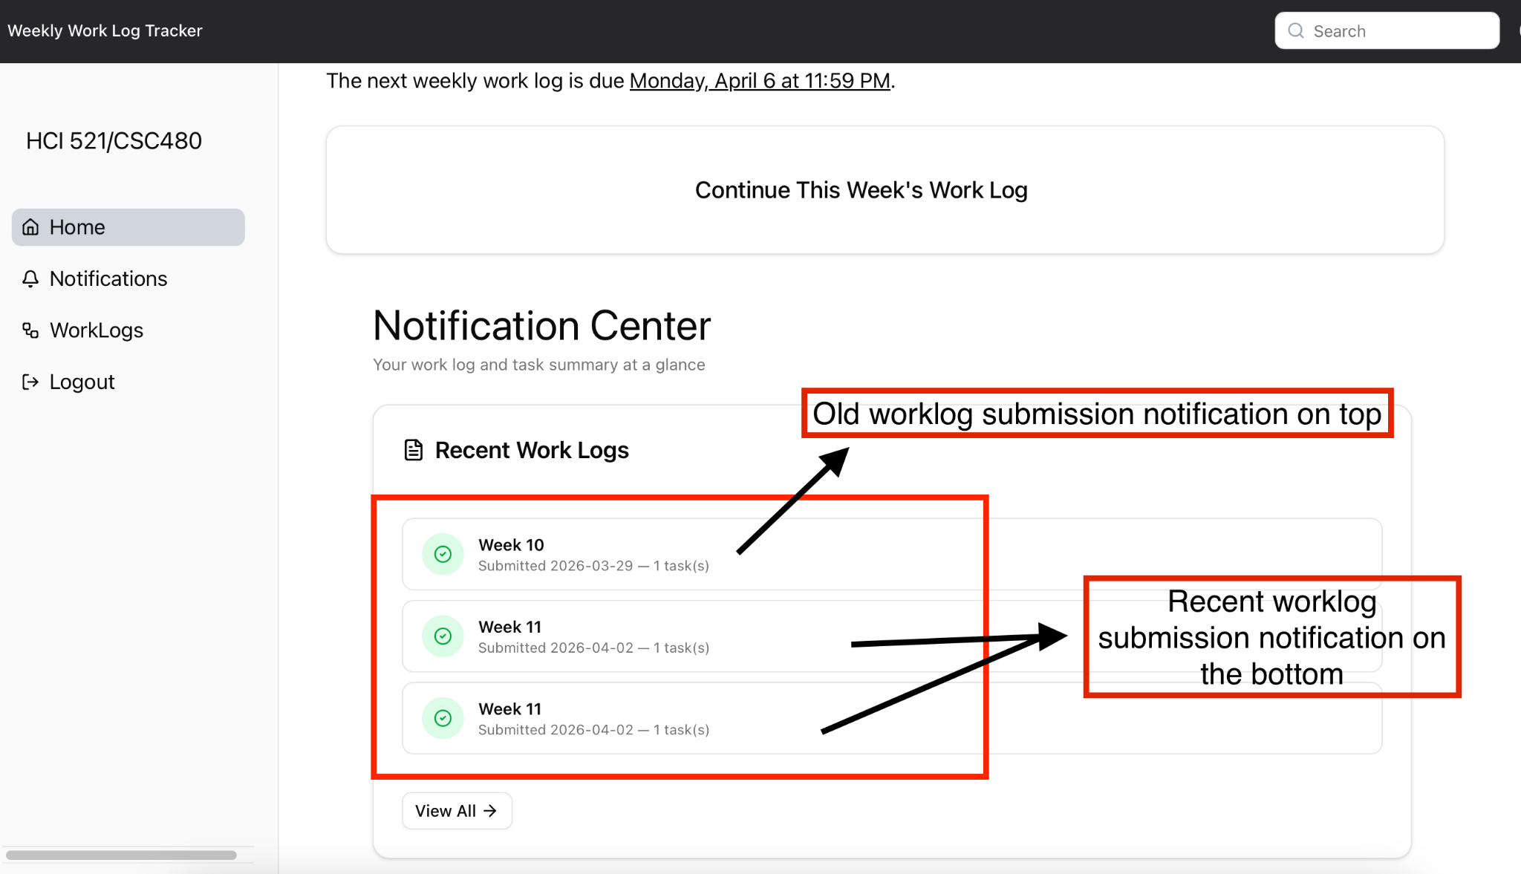

- When logged in w my personal id / instructor :
  - Could see the instructor's homepage
  - Could see the recent submission made by the student

Screenshot -
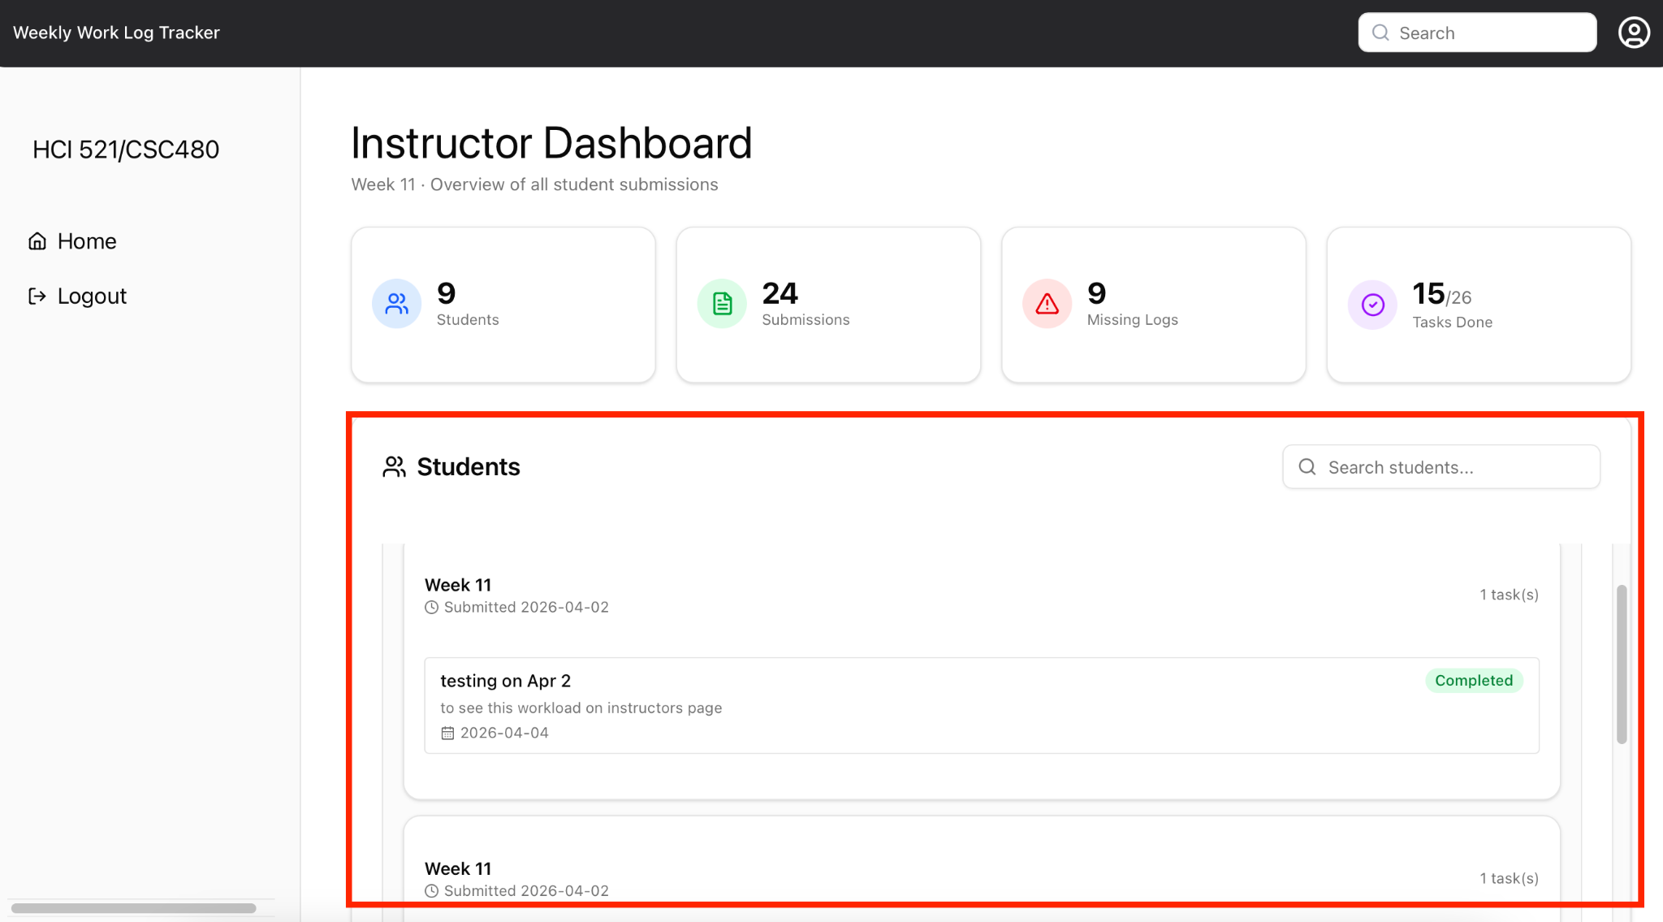

Additional Bug Found -

Where - Worklog form

Bug Description - When I was filling the worklog form, I noticed that -
The ‘Task 1’ heading was getting replaced by what I am typing in the task name.
Screenshot -
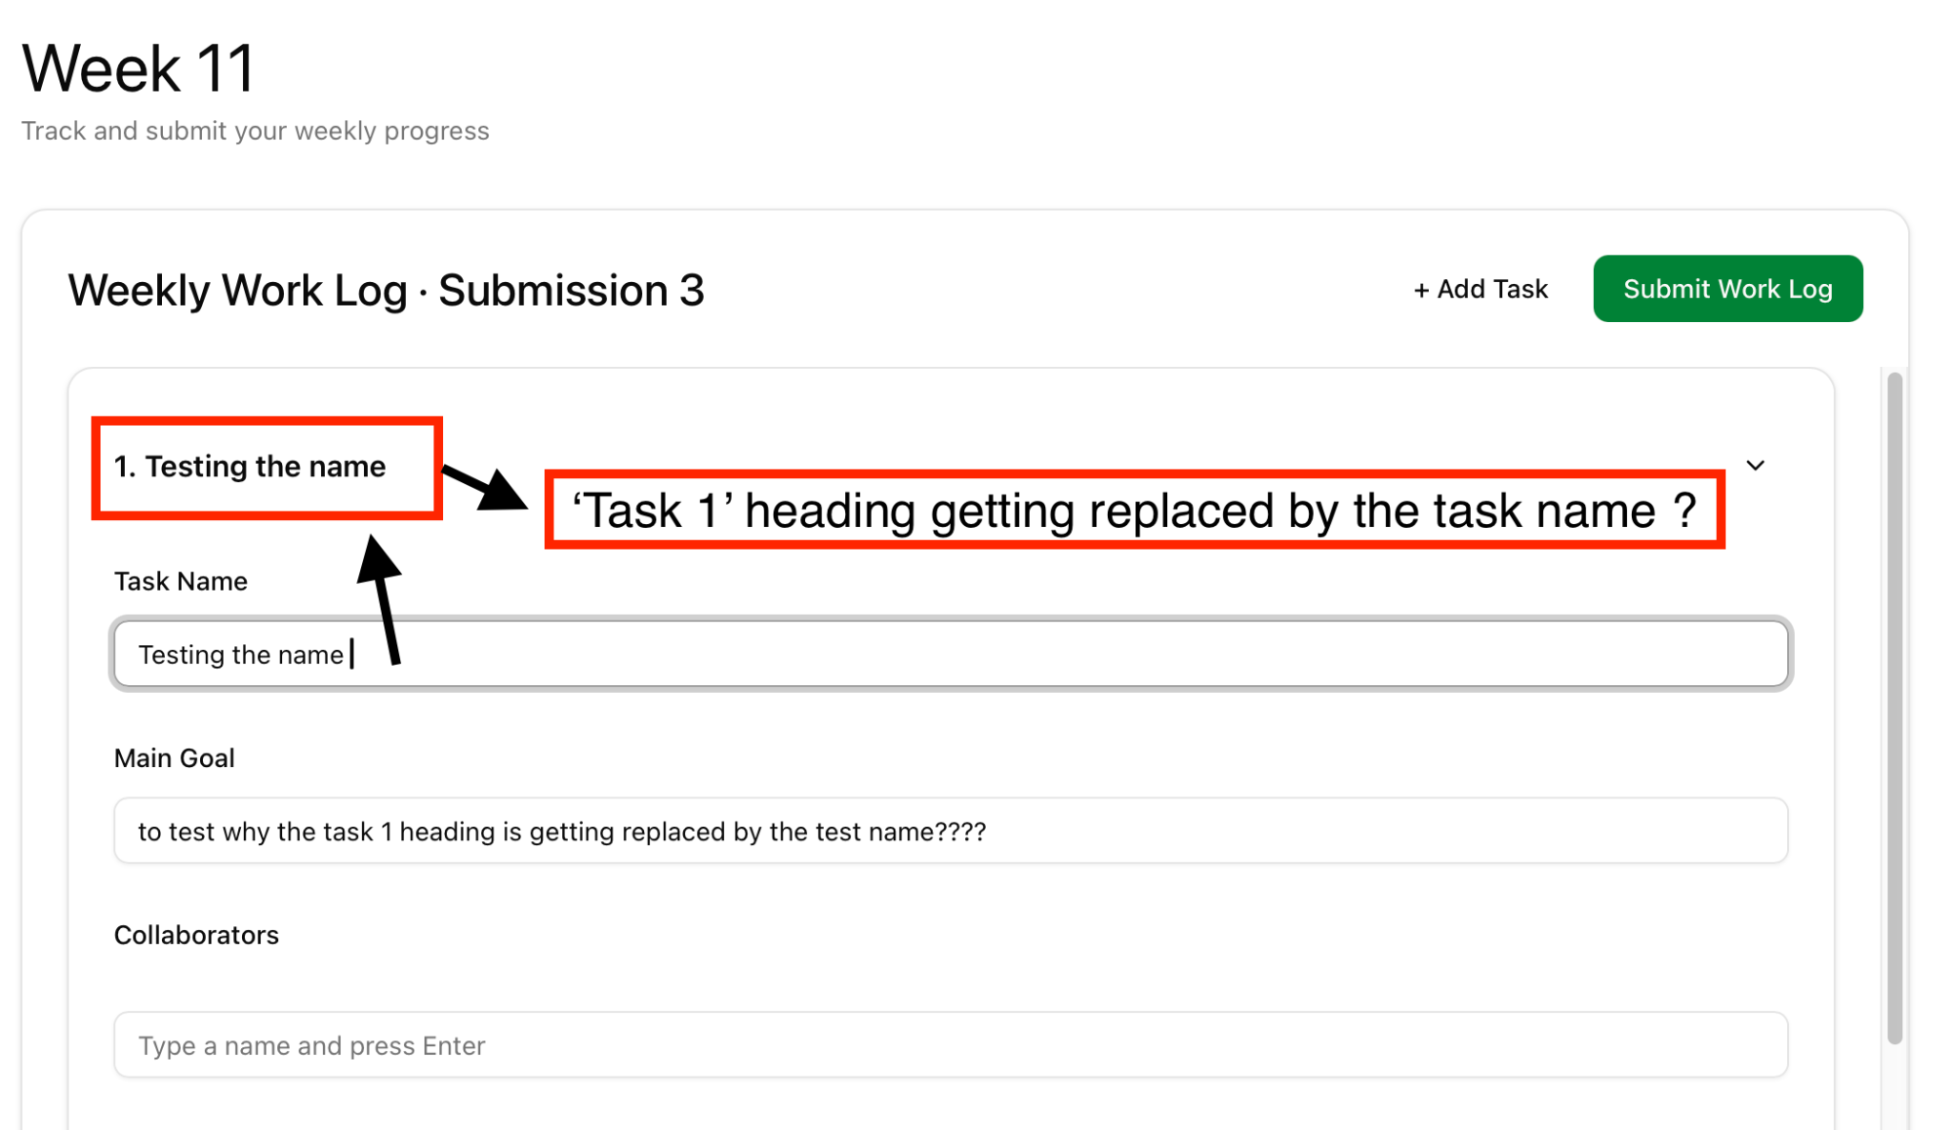

FR 2, 2.1, 2.4, 2.5

Requirement tested: FR 2
Description: The system shall generate a summary of weekly report submission status for instructors.
Build: v0.2.0_20260325
Determination: SUCCESSFUL

Setup:
- Open Safari browser on Mac OS
- Navigate to front-facing Moxie server (http://moxie.cs.oswego.edu:7000/)
- Execute test

Execution:
- Log in as an instructor.
- Navigate to the instructor home page.
- Wait for weekly report data to load.
- Observe the summary section.
- Verify the summary correctly reflects student submission statuses.

Expected Result:
Summary of submitted worklogs

Actual Result:
- When logged in:
  - Got logged in
  - Could see the submission summary

Screenshot: 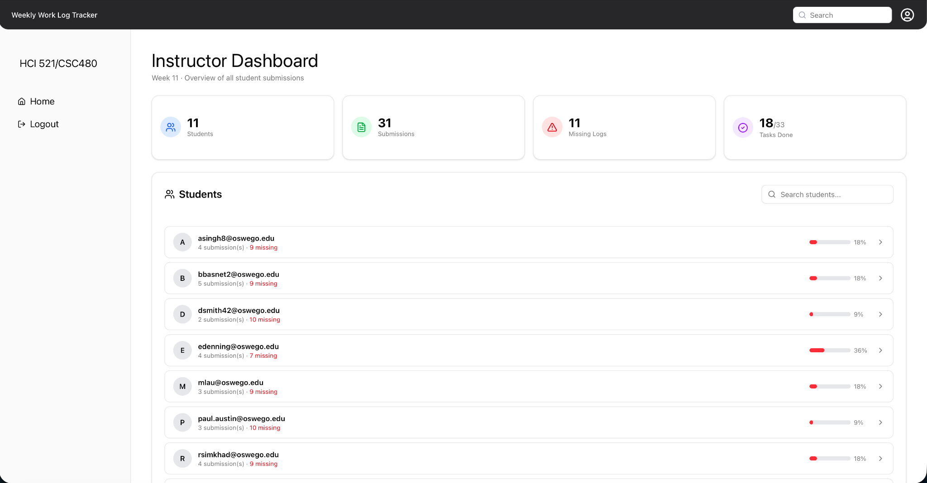

Requirement tested: FR 2.1
Description: The system shall receive a request to load the instructor home page.
Build: v0.2.0_20260325
Determination: SUCCESSFUL

Setup:
- Open Safari browser on Mac OS
- Navigate to front-facing Moxie server (http://moxie.cs.oswego.edu:7000/)
- Execute test

Execution:
- Log in as an instructor.
- Select the “Home” or dashboard option.
- Send the request to load the instructor home page.
- Wait for the system response.
- Verify the instructor home page loads successfully.

Expected Result:
Page loads and instructor home page becomes visible

Actual Result:
- When logged in:
  - Got logged in
  - Could see the instructor’s homepage

Screenshot: 

Requirement tested: FR 2.4
Description: The system shall aggregate weekly report statuses into a summarized view.
Build: v0.2.0_20260325
Determination: SUCCESSFUL

Setup:
- Open Safari browser on Mac OS
- Navigate to front-facing Moxie server (http://moxie.cs.oswego.edu:7000/)
- Execute test

Execution:
- Log in as an instructor.
- Navigate to the instructor dashboard.
- Allow the system to retrieve weekly report data.
- Wait for the summary to generate.
- Verify individual statuses are combined into an accurate summarized view.

Expected Result:
View the report is made in a summary format

Actual Result:
- When logged in:
  - Got logged in
  - Could see the instructor’s report with the summary in the home page

Screenshot: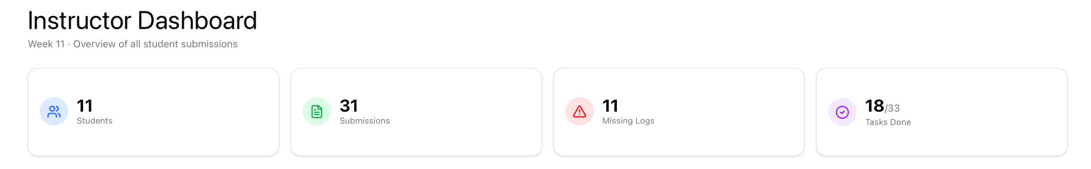

Requirement tested: FR 2.5
Description: If weekly report data retrieval fails, the system shall display a partial summary with an error message.
Build: v0.2.0_20260325
Determination: UNSUCCESSFUL

Setup:
Open Google Chrome on MacOS
Navigate to front-facing Moxie server (http://moxie.cs.oswego.edu:7000/)
Execute test

Execution:
- Log in as an instructor.
- Simulate a failure in weekly report data retrieval.
- Navigate to the instructor dashboard.
- Allow the system to attempt data retrieval.
- Verify a partial summary is displayed along with an appropriate error message.

Expected Result:
- When logged in as instructor
  - Error message is displayed on components that fetches data from backend including Homepage, Notification Page

Actual Result:
- When logged in as an instructor :
  - Right click and choose “inspect”
  - Go to the Network Section
  - At API right click and choose block it

Bug Found :
The website didn’t show any error message instead it just showed a no submission message. That’s should happen as we disconnect the API and the frontend

Screenshot - 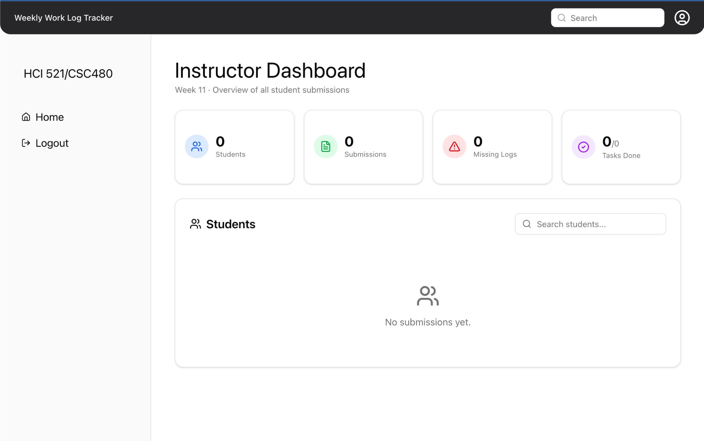

FR 3.1, 3.2, 3.3, 3.4

Requirement tested: FR 3.1
Description: The system shall retrieve the current reporting period for the student.
Build: v0.2.0_20260402
Determination: UNSUCCESSFUL

Setup:
- Open Chrome browser on Mac OS
- Navigate to front-facing Moxie server (http://moxie.cs.oswego.edu:7000/)
- Execute test

Execution:
- Log in as a student.
- Navigate to the Student Home Page.
- Observe the displayed reporting period.
- Compare displayed reporting period with expected current period (from test data or database).

Expected Result:
Week number and date should show in both the Homepage and Notification page for the student dashboard.
What to expect : Week number and date

Actual Result:
- The due date on the homepage is correct
- The due date on the notification page is incorrect and off by a week/one of the worklog is wrong

Screenshot: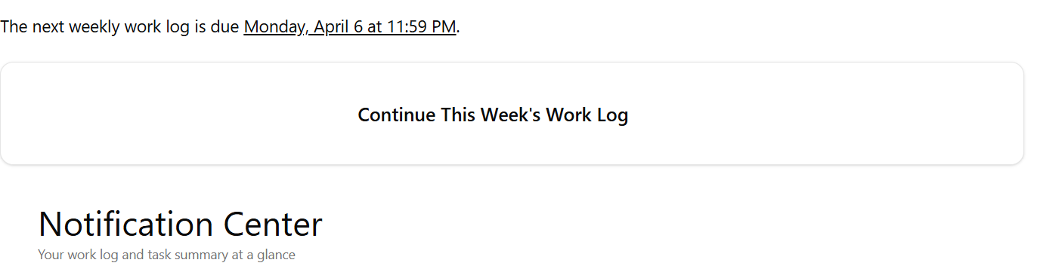
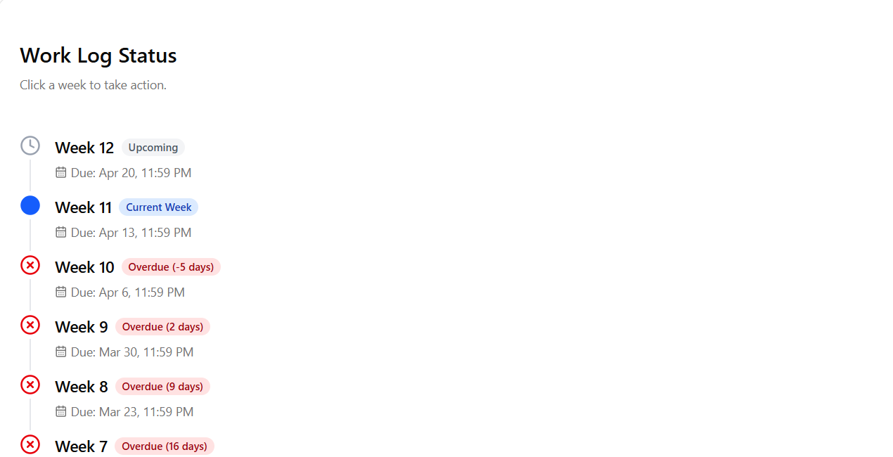

Requirement tested: FR 3.2
Description: The system shall retrieve the student’s weekly report for the current reporting period.
Build: v0.2.0_20260402
Determination: SUCCESSFUL

Setup:
- Open Chrome browser on Mac OS
- Navigate to front-facing Moxie server (http://moxie.cs.oswego.edu:7000/)
- Execute test

Execution:
- Log in as a student with an existing weekly report for the current period.
- Navigate to the Student Home Page.
- Locate the weekly report section.
- Observe report data displayed.

Expected Result:
The student sees the weekly report for that week
What to expect : Weekly report on the notification Page

Actual Result:
- I was able to see all the worklogs in the notification page
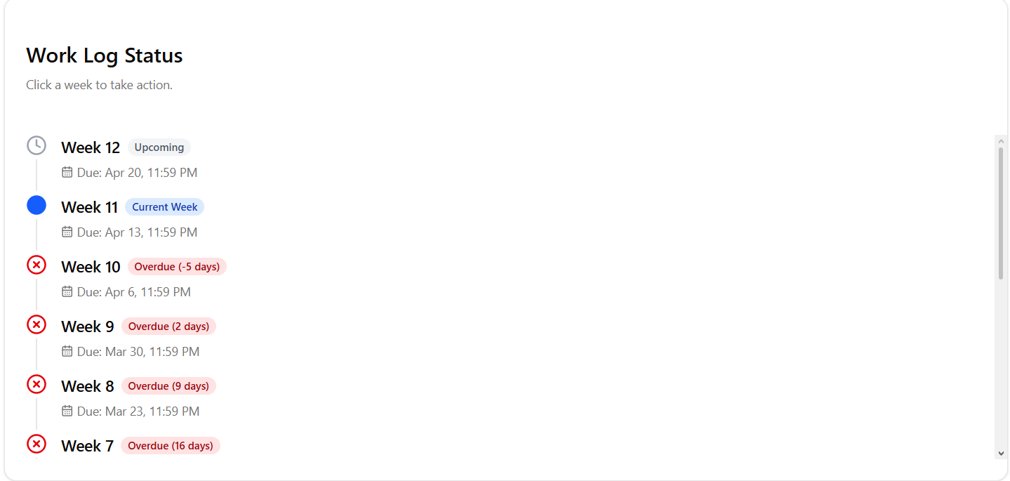
Screenshot:

Requirement tested: FR 3.3
Description: The system shall determine the report status based on the presence of required fields.
Build: v0.2.0_20260402
Determination: SUCCESSFUL

Setup:
- Open Chrome browser on Mac OS
- Navigate to front-facing Moxie server (http://moxie.cs.oswego.edu:7000/)
- Execute test

Execution:
- Log in as a student.
- Create a weekly report.
- Fill in all required fields.
- Save or submit the report.
- Return to the Student Home Page.
- Observe the report status.

Expected Result:
The system updates the report status of student submits or saves
What to expect : status change

Actual Result:
- Submission status changed to a checkmark after submitting the report.

Screenshot:
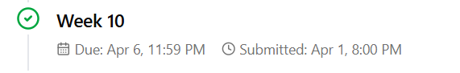

Requirement tested: FR 3.4
Description: The system shall retrieve the current reporting period for the student.
Build: v0.2.0_20260402
Determination: SUCCESSFUL

Setup:
- Open Chrome browser on Mac OS
- Navigate to front-facing Moxie server (http://moxie.cs.oswego.edu:7000/)
- Execute test

Execution:
- Log in as a student with NO weekly report for the current period.
- Navigate to the Student Home Page.
- Observe the report status section.

Expected Result:
The system should display a "overdue" message if student didn't submit a weekly report
What to expect : A red cross button next to not submitted worklogs

Actual Result:
- There is an overdue message along with how many days and also a bid cross next to the work log

Screenshot:
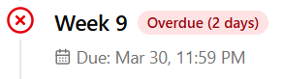

FR 4.3

STP Test Case # ST-4

Requirement tested: FR 4.3
Description: The system shall prevent incomplete weekly reports from being marked as complete.
Build: v0.2.0_20260402
Determination: SUCCESSFUL

Setup:
- Open Chrome on Windows OS
- Navigate to front-facing Moxie server (http://moxie.cs.oswego.edu:7000/)
- Execute test

Execution:
- Log in with valid student id
- Go to Notifications tab
- Select a missing assignment
- Click start worklog
- Fill in worklog info leaving out some sections making it incomplete
- Click submit worklog
- View the system doesn’t allow you to submit incomplete worklog
- Go to notifications page
- View the previously selected missing worklog is still missing

Expected Result:
If incompleted worklog is attempted to be submitted the notification page remains as worklog missing.
What to expect : Red X next to specified worklog in notification center

Actual Result:
Worklog failed to submit and worklog status remained unchanged in Notification center

Screenshot:
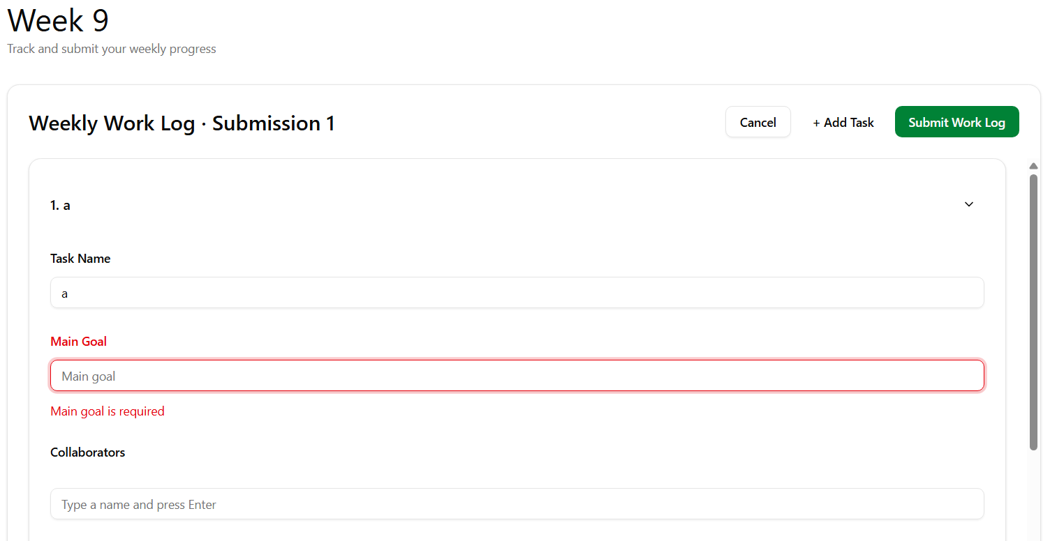

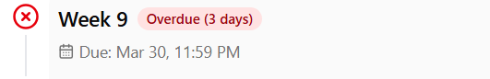

FR: 5.1, 5.2, 5.3
STP Test Case # ST-4
Requirement tested: FR-5.1
Description: The system shall verify that the required worklog structure exists before submission.
Build: v0.2.0_20260325
Determination: SUCCESSFUL

Setup:

- Open the Chrome browser on Windows OS
- Navigate to front-facing Moxie server (http://moxie.cs.oswego.edu:7000/)
- Execute test

Execution:
- Log in as a student.
- Navigate to the Weekly Work Logs / WorkLogs page.
- Open any weekly work log submission form.
- Observe the required fields and sections shown before submission.

Expected result:

The worklog submission form should display the required worklog structure before submission, including required fields (Task Name, Main Goal, Deadline, Completion, Reflection).

Actual result

The weekly work log submission form displayed the required worklog structure before submission. Required fields were visible on the form (Task Name, Main Goal, Deadline, Completion, Reflection), and the user was able to access the full submission layout prior to clicking “Submit Work Log.”

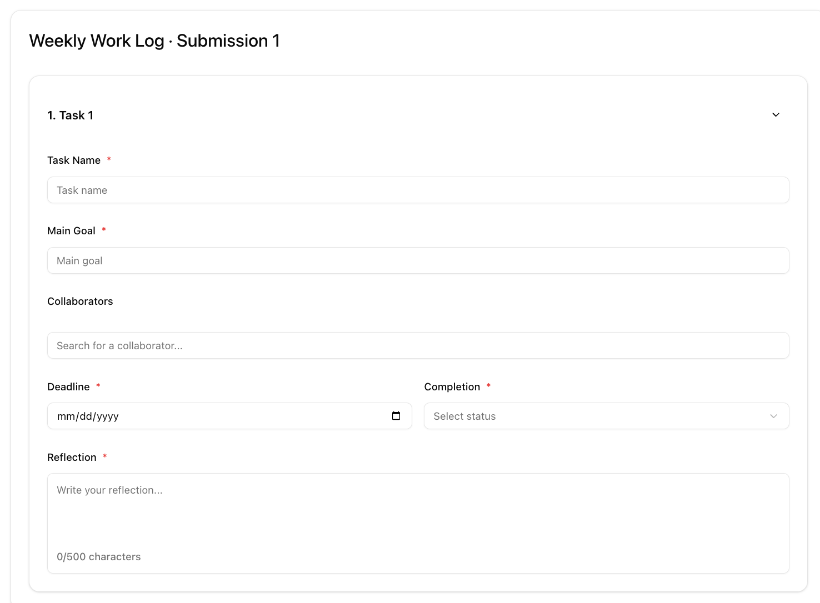
Fig. (5.1): Weekly Work Log submission form showing required worklog structure before submission (Task Name, Main Goal, Collaborators, Deadline, Completion, Reflection).

STP Test Case # ST-4
Requirement tested: FR-5.2
Description: The system shall allow worklogs containing tasks of incomplete status to be submitted.
Build: v0.2.0_20260325
Determination: SUCCESSFUL

Setup:

- Open the Chrome browser on Windows OS
- Navigate to front-facing Moxie server (http://moxie.cs.oswego.edu:7000/)
- Execute test

Execution:
- Log in as a student.
- Open the Weekly Work Logs / WorkLogs page.
- Open the weekly work log submission form.
- Fill required fields (Task Name, Main Goal, Deadline, Reflection).
- Set task Completion to Not Started (or In Progress).
- Click Submit Work Log.
- Return to the WorkLogs page and confirm the submission appears with the task still incomplete.

Expected result:

User should be able to submit a worklog even if the task completion status is incomplete (Not Started/In Progress), and the submitted worklog should still display the incomplete completion status.

Actual result

The worklog was successfully submitted while the task completion status remained Not Started (or In Progress). The submission appeared in the WorkLogs list with a submitted date, confirming that incomplete tasks do not block submission.

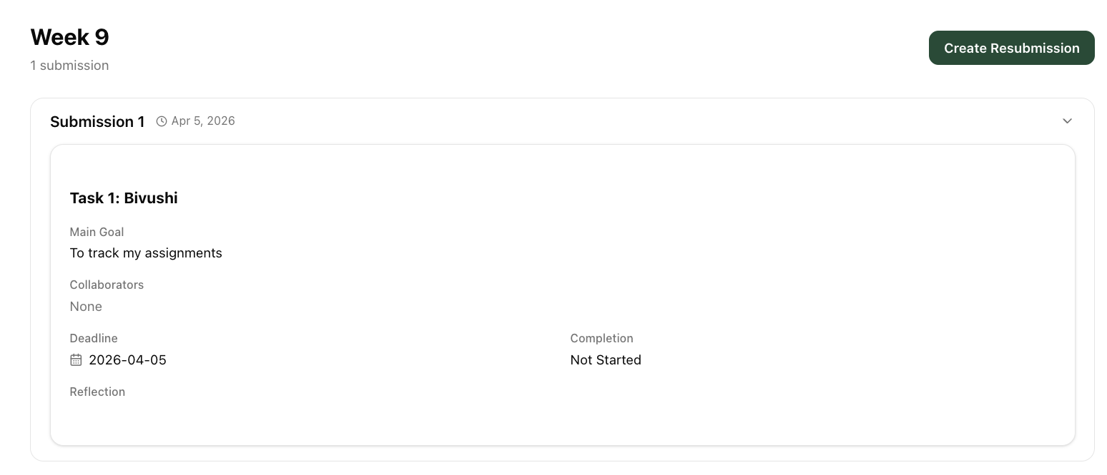

Fig. (5.2): Submitted weekly work log (Week 9, Submission 1) showing task completion status as Not Started, confirming incomplete tasks can still be submitted.

STP Test Case # ST-4
Requirement tested: FR-5.3
Description: The system shall store task completion status independently of worklog submission status.
Build: v0.2.0_20260325
Determination: SUCCESSFUL

Setup:

- Open the Chrome browser on Windows OS
- Navigate to front-facing Moxie server (http://moxie.cs.oswego.edu:7000/)
- Execute test

Execution:

- Log in as a student.
- Open the Weekly Work Logs / WorkLogs page.
- View multiple submitted work log submissions.
- Observe the Completion status shown for tasks in each submission.

Expected result:

User should be able to view submitted work logs while tasks inside them still show independent completion statuses (Completed / Not Started / In Progress), confirming task completion is tracked separately from submission status.

Actual result

Multiple submitted work log submissions were visible, and tasks inside the submissions displayed different Completion statuses (example shown: one submission marked Completed, another marked Not Started, and another marked In Progress), confirming task completion status is stored independently of worklog submission status.

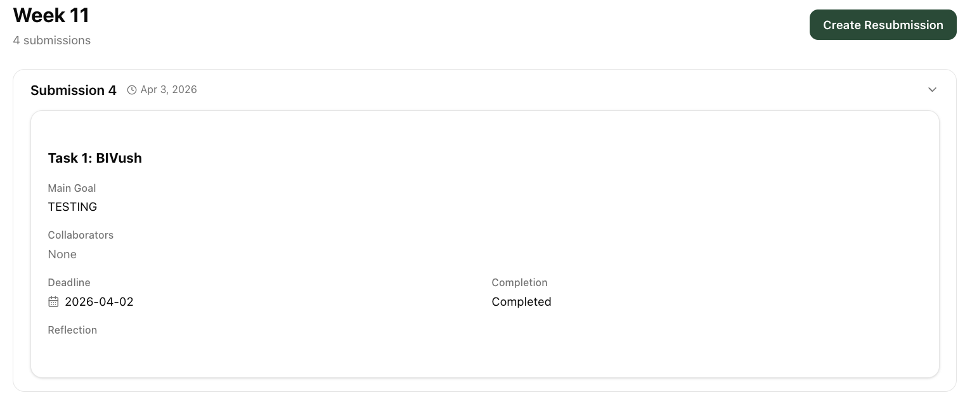

Fig. (5.3(a)): Submitted work log details showing task-level completion status (e.g., Completion: Completed) inside a submission, confirming task completion is stored independently of submission status.

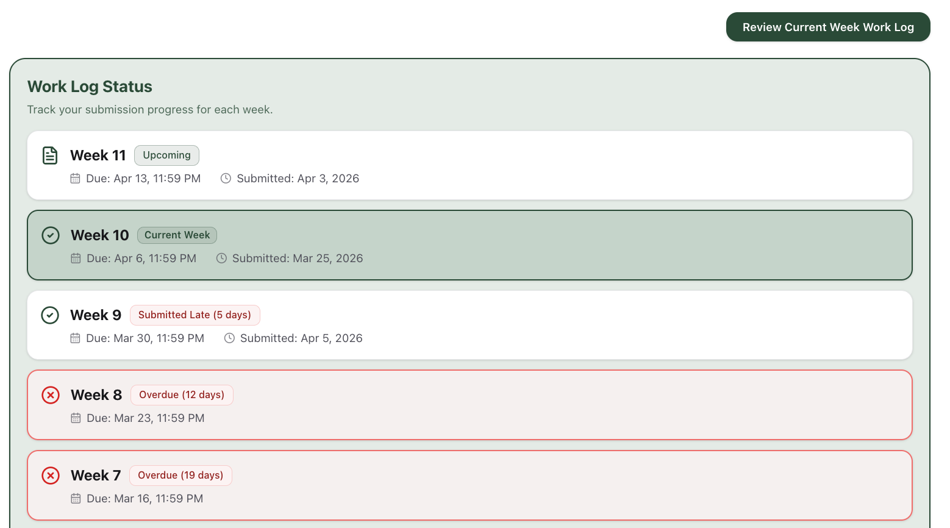

Fig. (5.3a): Work Log Status page showing submission status tracked separately (e.g., Week 9 marked Submitted Late (5 days) with due and submitted dates).

FR 6
STP Test Case # ST-4
Requirement tested: FR-6
Description: The system shall handle errors occurring during home page data retrieval.
Build: v0.2.0_20260325
Determination: UNSUCCESSFUL

Setup:

- Open Chrome browser on Mac
- Navigate to Moxie server (http://moxie.cs.oswego.edu:7000/)
- Execute test

Execution:

- Log in as a student.
- Right click → Inspect.
- Go to the Network tab.
- Refresh the page once so API calls appear.
- Find the API request (fetch/XHR).
- Right-click on that API request.
- Click Block request URL.
- Refresh the page again and check.

Expected Result:
The system shall display an appropriate error message when an API call fails during home page data retrieval. The message shall clearly indicate that the data could not be retrieved.
Actual Result:
The system did not display an error message indicating that data could not be retrieved. Instead, it incorrectly displayed “No worklog submitted yet,” even though a worklog had already been submitted.

Screenshot:
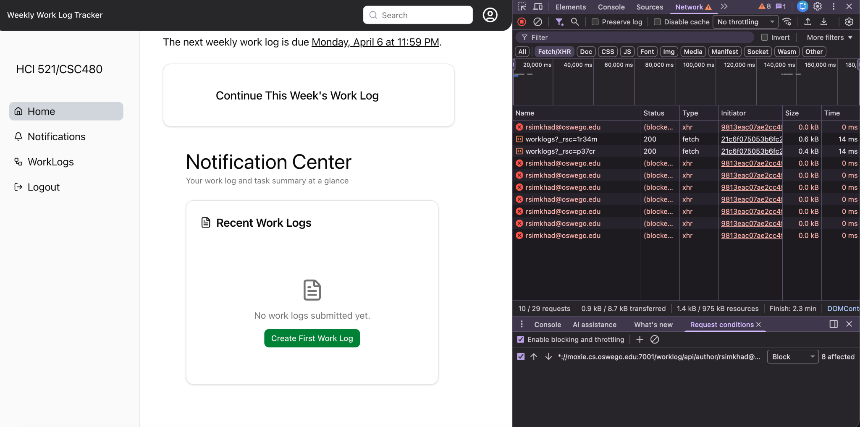

FR 8.1, 8.2, 13
STP Test Case # ST-4
Requirement tested: FR-8.1
Description: The system shall log home page load events.
Build: v0.1.0_20260304
Determination: UNSUCCESSFUL

Setup:
- Open Chrome browser on MacOS
- Navigate to front-facing Moxie server (http://moxie.cs.oswego.edu:7000/)
- Execute test

Execution:
- Log onto the moxie server
- refresh/ loaded the server
- Look for a loading message on the home page

Expected Results:
- A log entry is created each time the home page is loaded.
- The log has information such as load event triggered, timestamp of the event, Event status

Actual Results:
There was no “loading” message whenever the server was refreshed

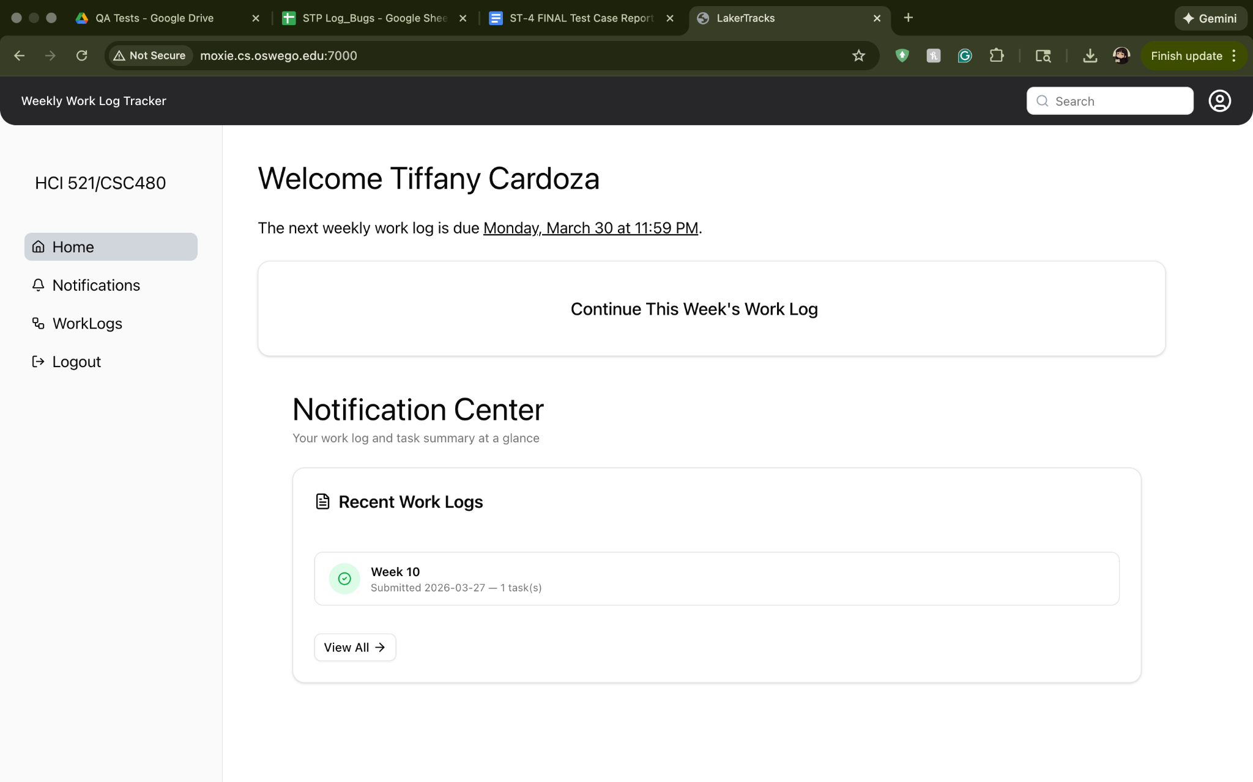
Screenshots:
Before and after refreshing

During refresh
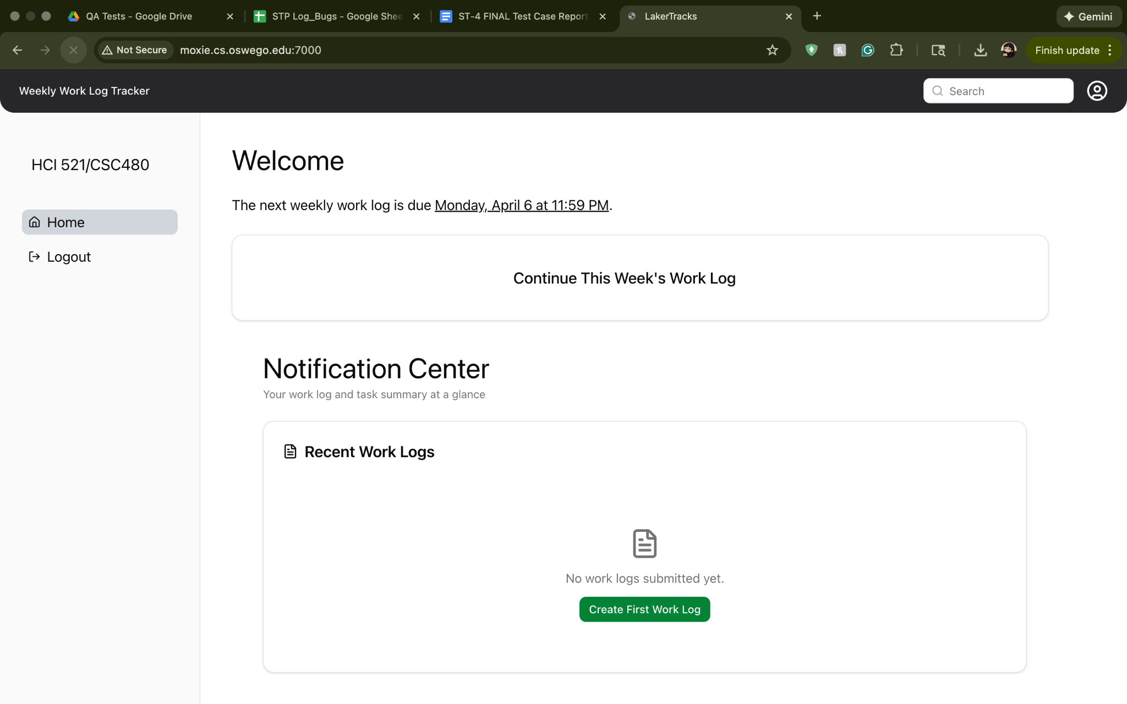

STP Test Case # ST-4
Requirement tested: FR-8.2
Description: The system shall log data retrieval failures related to home page loading.
Build: v0.1.0_20260304
Determination: UNSUCCESSFUL

Setup:
- Open Chrome browser on MacOS
- Navigate to front-facing Moxie server (http://moxie.cs.oswego.edu:7000/)
- Execute test

Execution:
- Log onto the moxie server
- Turned off my wifi
- Tried clicking around to find an error message

Expected Results:
1. If homepage data fails, log should be generated.
2. The log has information such as event type triggered, failure reason, timestamp of the event, event status
3. An error message should be displayed

Actual Results:
When I clicked around to either make, save, or do anything on the page i was on, it didn't do anything. No error message, no reaction, but when i clicked a different page i get the normal disconnected from wifi message

Screenshots:

Wifi on:
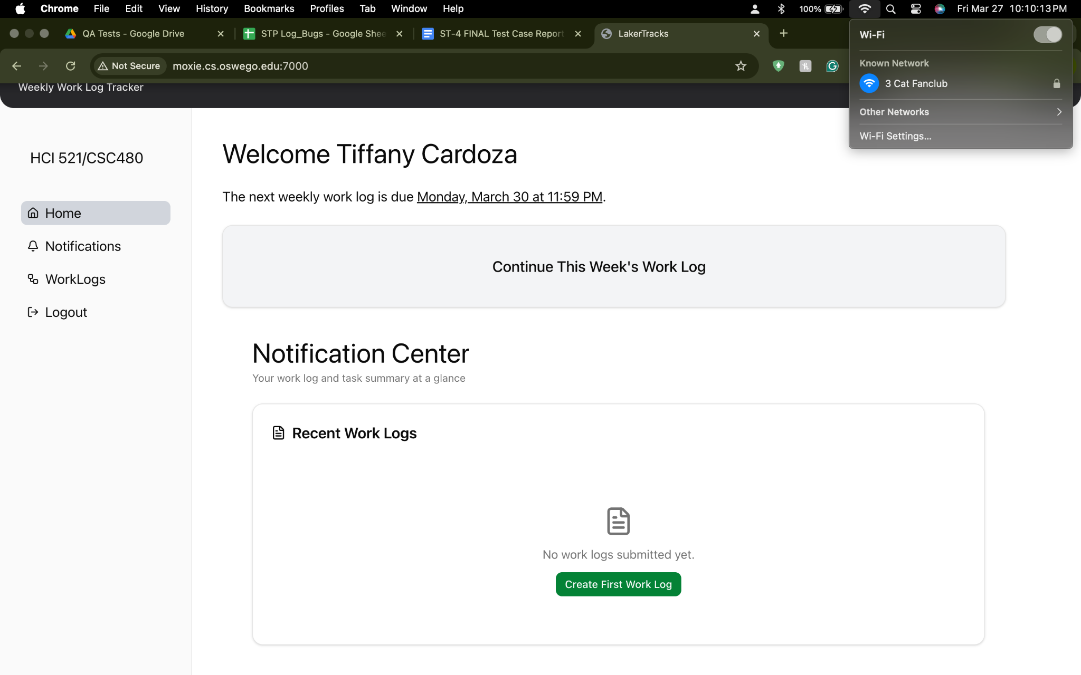
Wifi off and i try to retrieve anything:
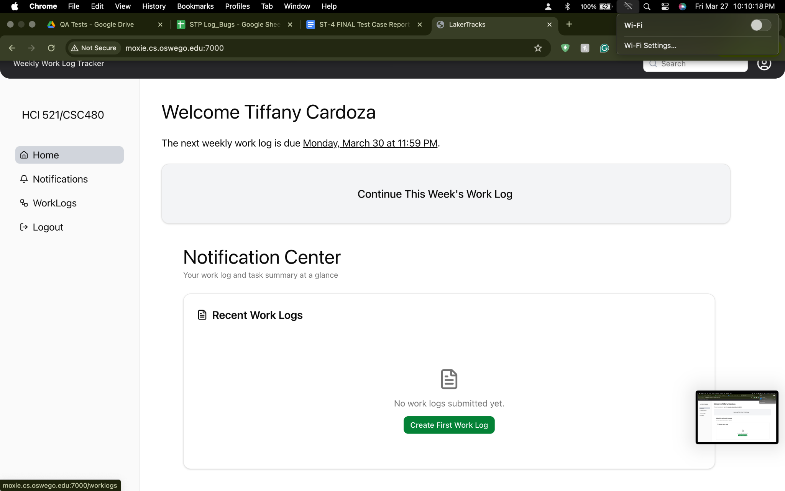
When wifi is off and i click a different page
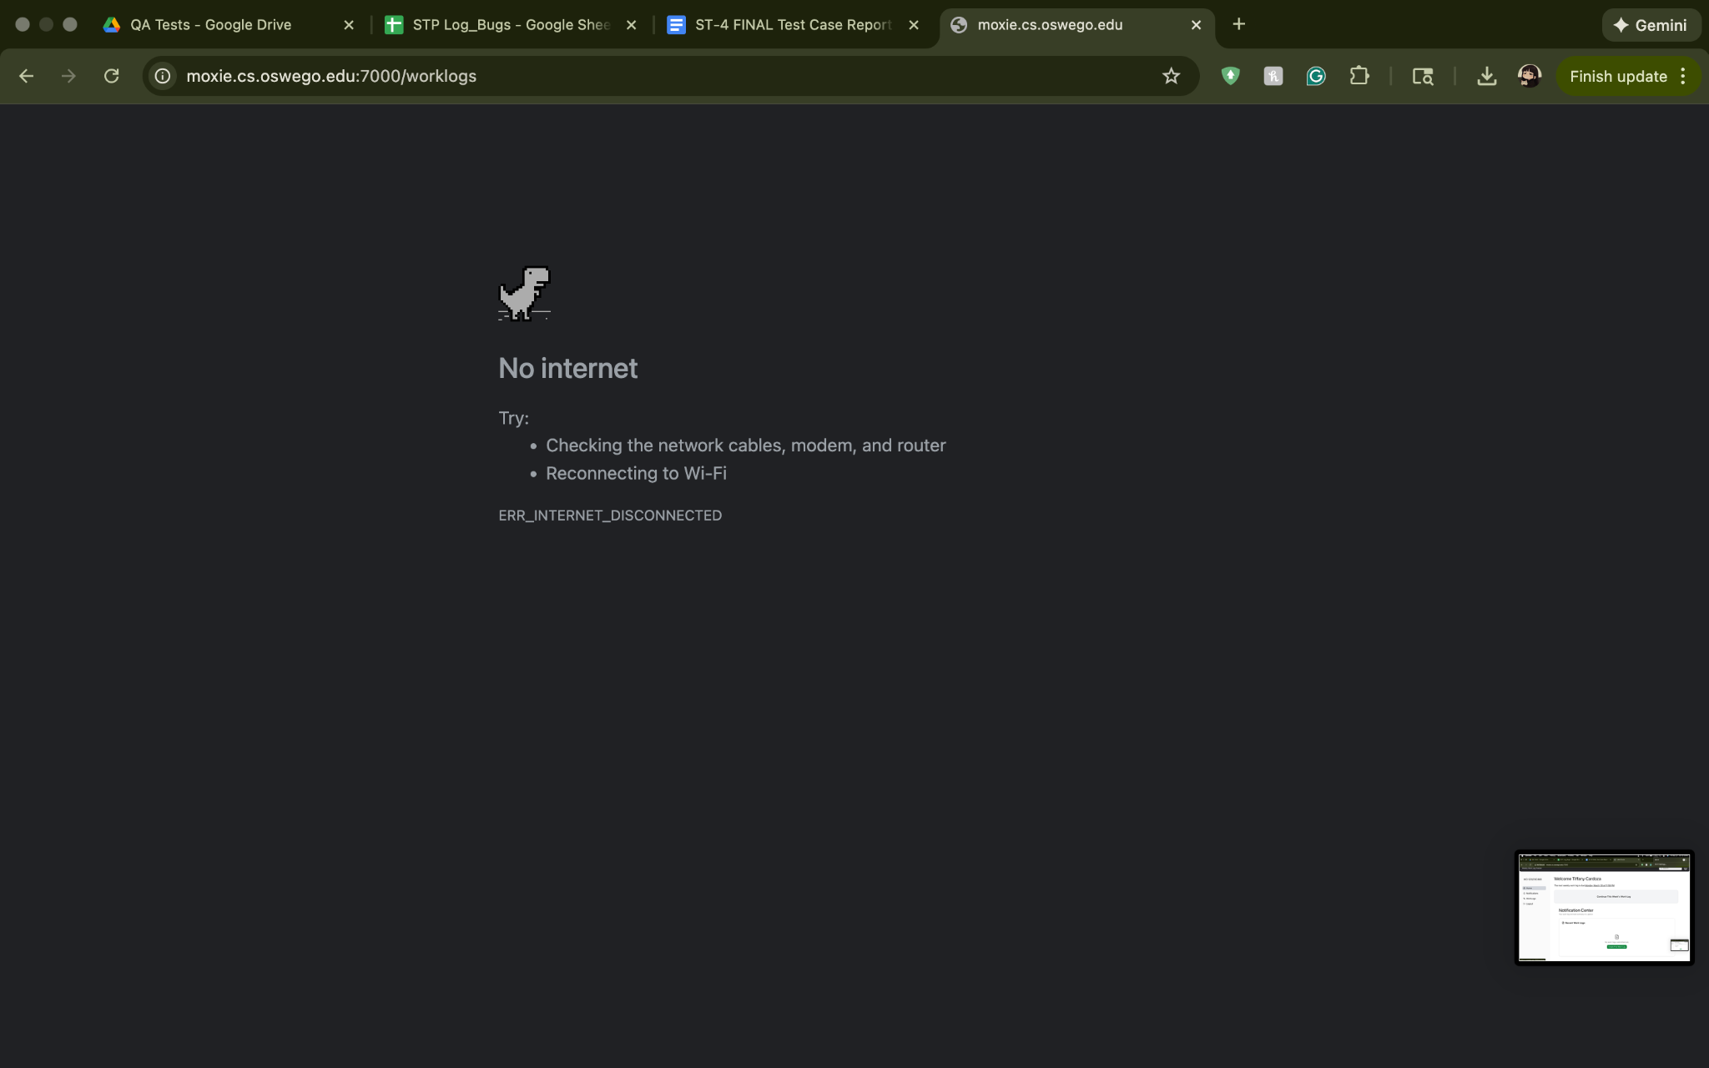

FR 9, 9.1
STP Test Case # ST-4

Requirement tested: FR-9
Description: The system shall allow a student to submit a worklog.
Build: v0.2.0_20260325
Determination: SUCCESSFUL

Setup:

- Open Chrome browser on Windows OS
- Navigate to front-facing Moxie server (http://moxie.cs.oswego.edu:7000/)
- Execute test

Execution:

- Log in as a student.
- Navigate to the Worklogs page.
- Fill in required worklog fields.
- Click Submit Worklog.
- Check the Notifications page to see submission.
- Log out.
- Log in as Instructor.
- Navigate to Notifications page.
- Check that your most recent student submission was successful.

Expected Result:

User should be able to submit a worklog and see that the system saves the submission. Instructor should be able to view the submission.

Actual Result:

Student is able to submit a worklog and it is saved. Instructor is able to see that the student submitted a worklog but is unable to view its details.

Screenshot 1: Student is able to submit a worklog.
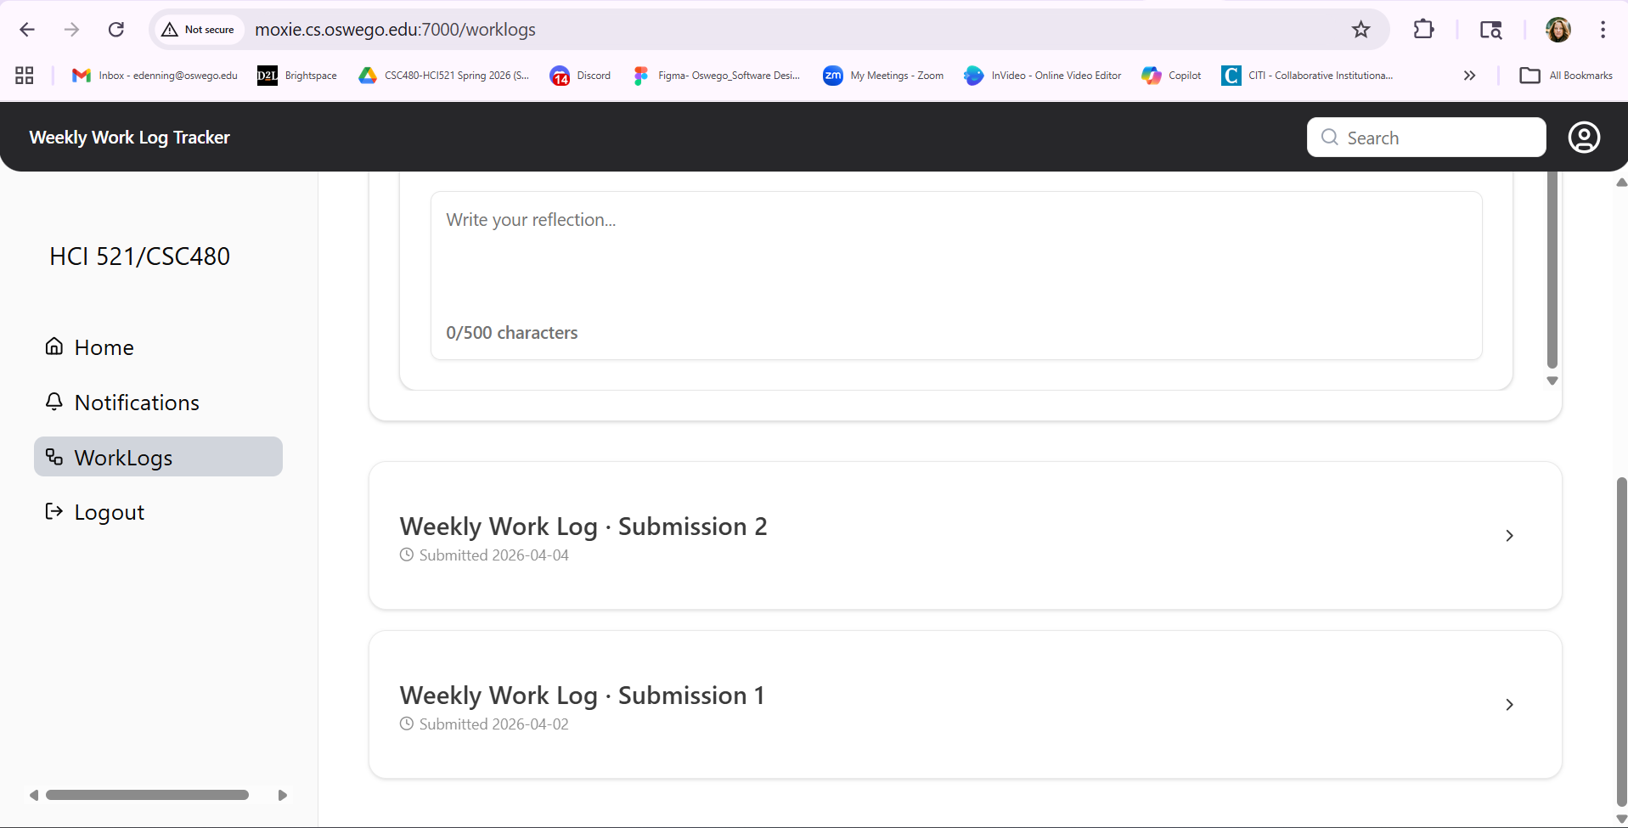
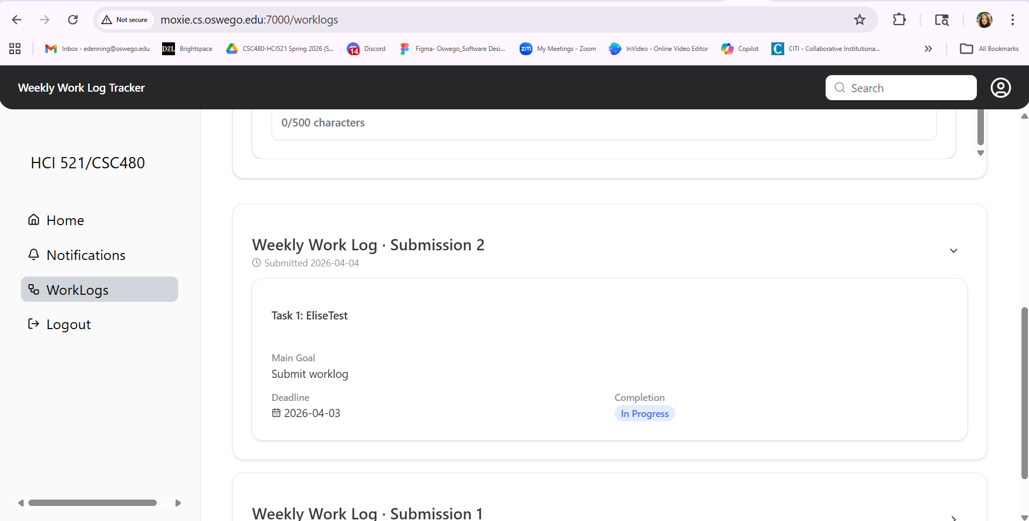

Screenshot 2: Instructor is able to see that a worklog was submitted.
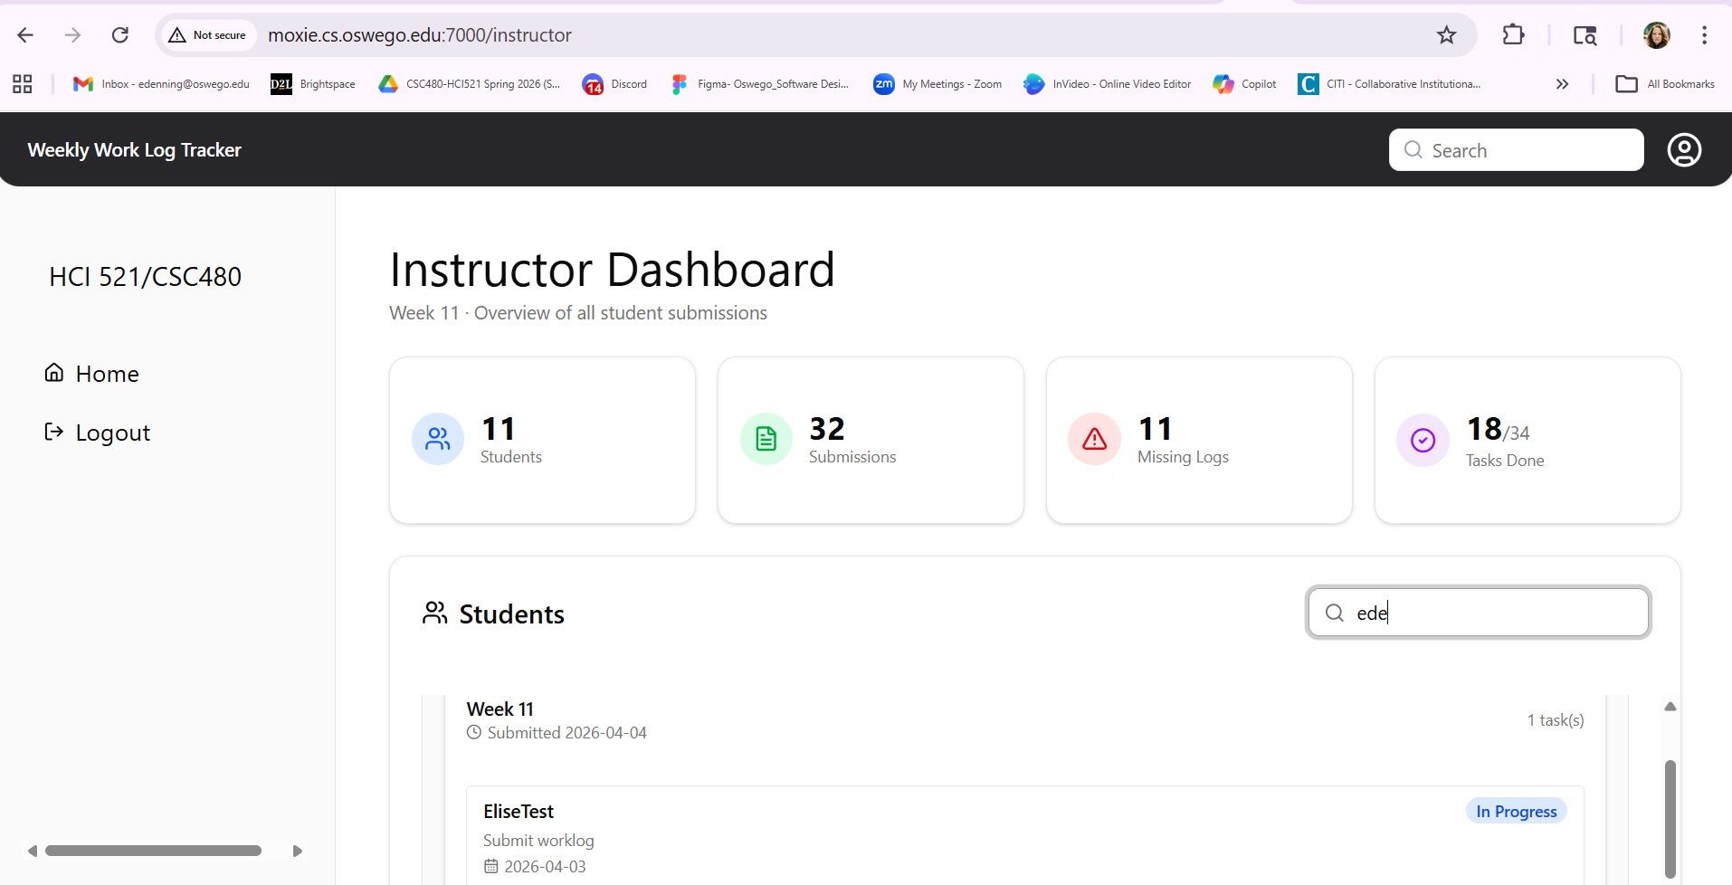

Requirement tested: FR-9.1
Description: The system shall record the timestamp when a worklog is submitted.
Build: v0.2.0_20260325
Determination: PARTIALLY SUCCESSFUL

Setup:

- Open Chrome browser on Windows OS
- Navigate to front-facing Moxie server (http://moxie.cs.oswego.edu:7000/)
- Execute test

Execution:

- Log in as a student.
- Navigate to the Worklogs page.
- Fill in required worklog fields.
- Click Submit Worklog.
- Open the submitted worklog (or submission confirmation/details page).
- Observe the submission timestamp shown next to worklog submission on Notification page.

Expected Result:

User should be able to submit a worklog and see that the system records a submission timestamp, and the timestamp shown should match the date/time the worklog was submitted. Timestamp should be seen on the Notification page, next to each submitted worklog.

Actual Result:

On the Notifications page, it listed my worklog submission but had the wrong date and time. The date/time should have read: April 2, 5:45pm.

Screenshot # 1:
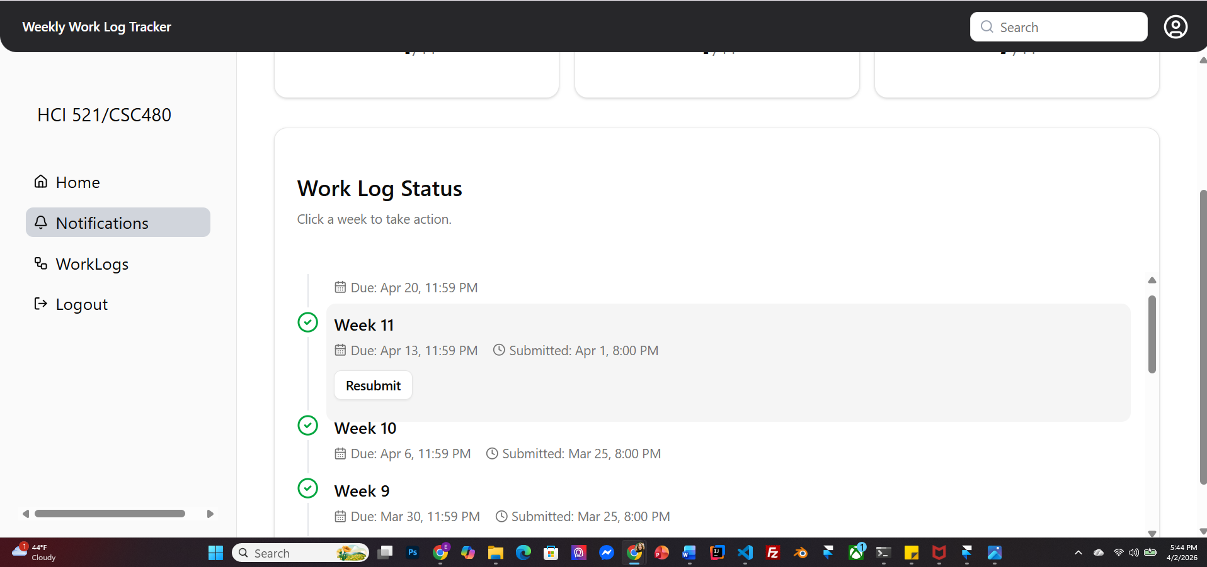

FR 10, 10.1, 10.2, 10.3
STP Test Case # ST-4
Requirement tested: FR-10
Description: The system shall store each submitted worklog as a new version.
Build: v0.2.0_20260325
Determination: SUCCESSFUL

Setup:

- Open Chrome browser on Mac
- Navigate to Moxie server (http://moxie.cs.oswego.edu:7000/)
- Execute test

Execution:
As a student -
- Navigate to worklog page
- Submit a worklog
- Re-submit another worklog (for the same week)
As an Instructor -
1. Ensure the student has submitted multiple worklogs.
2. Navigate to a student’s worklog with multiple submissions.
3. View the version list / submission based on time

Expected Result:
As a student -
1. A new version should be created for each submission.
2. The previous version should not be overwritten.
As an Instructor -
1. The instructor shall see multiple versions.
2. Each submission should appear as a separate version.
3. Older versions should remain unchanged.

Actual Result:
As a student, a new version was created for each submission, and the previous versions were not overwritten.
As an instructor, multiple versions were visible, each submission appeared as a separate version, and older versions remained unchanged.
Screenshot: For student-

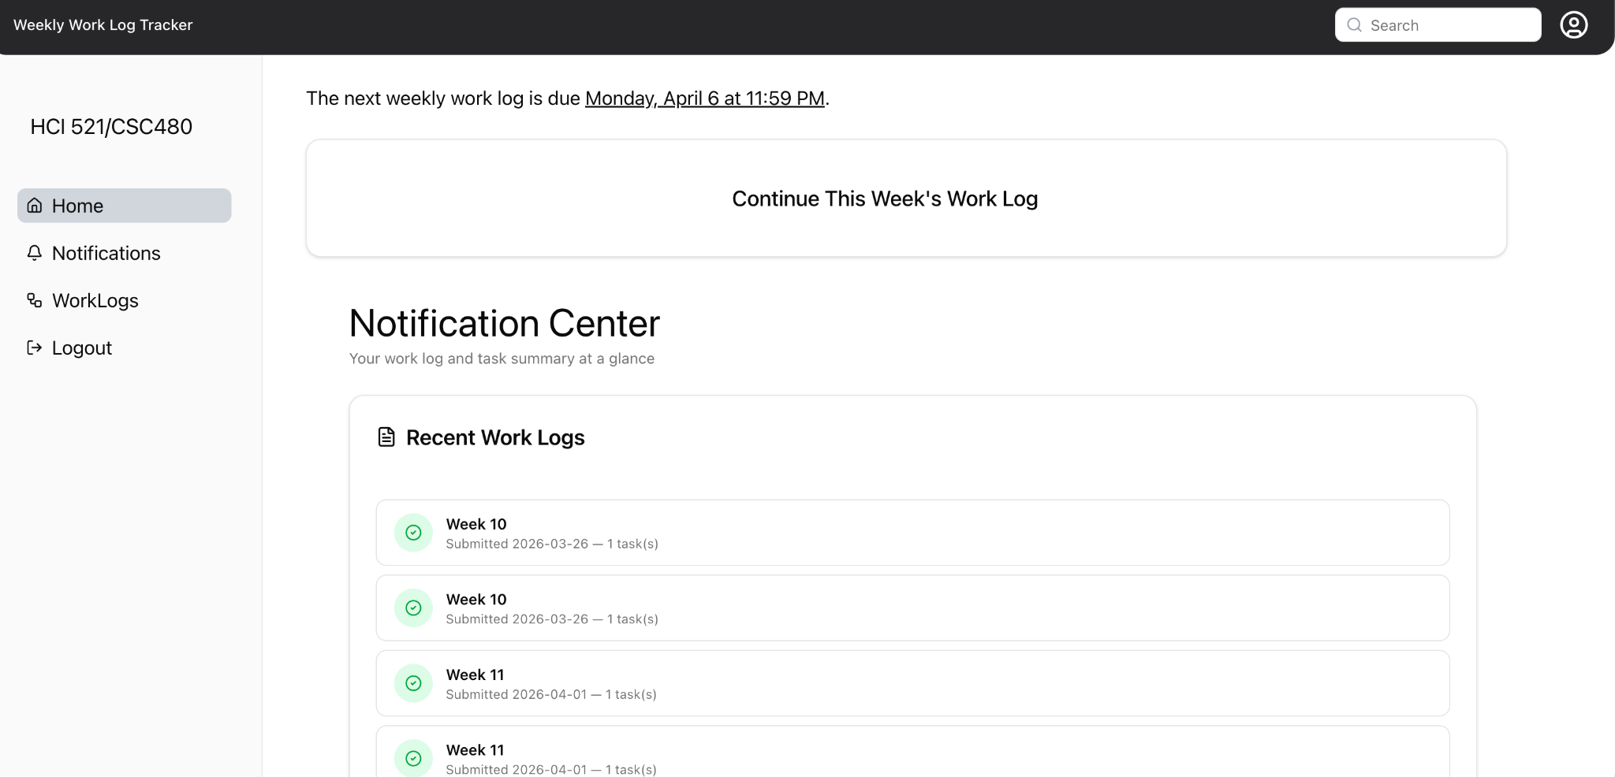

Screenshot: For instructor-
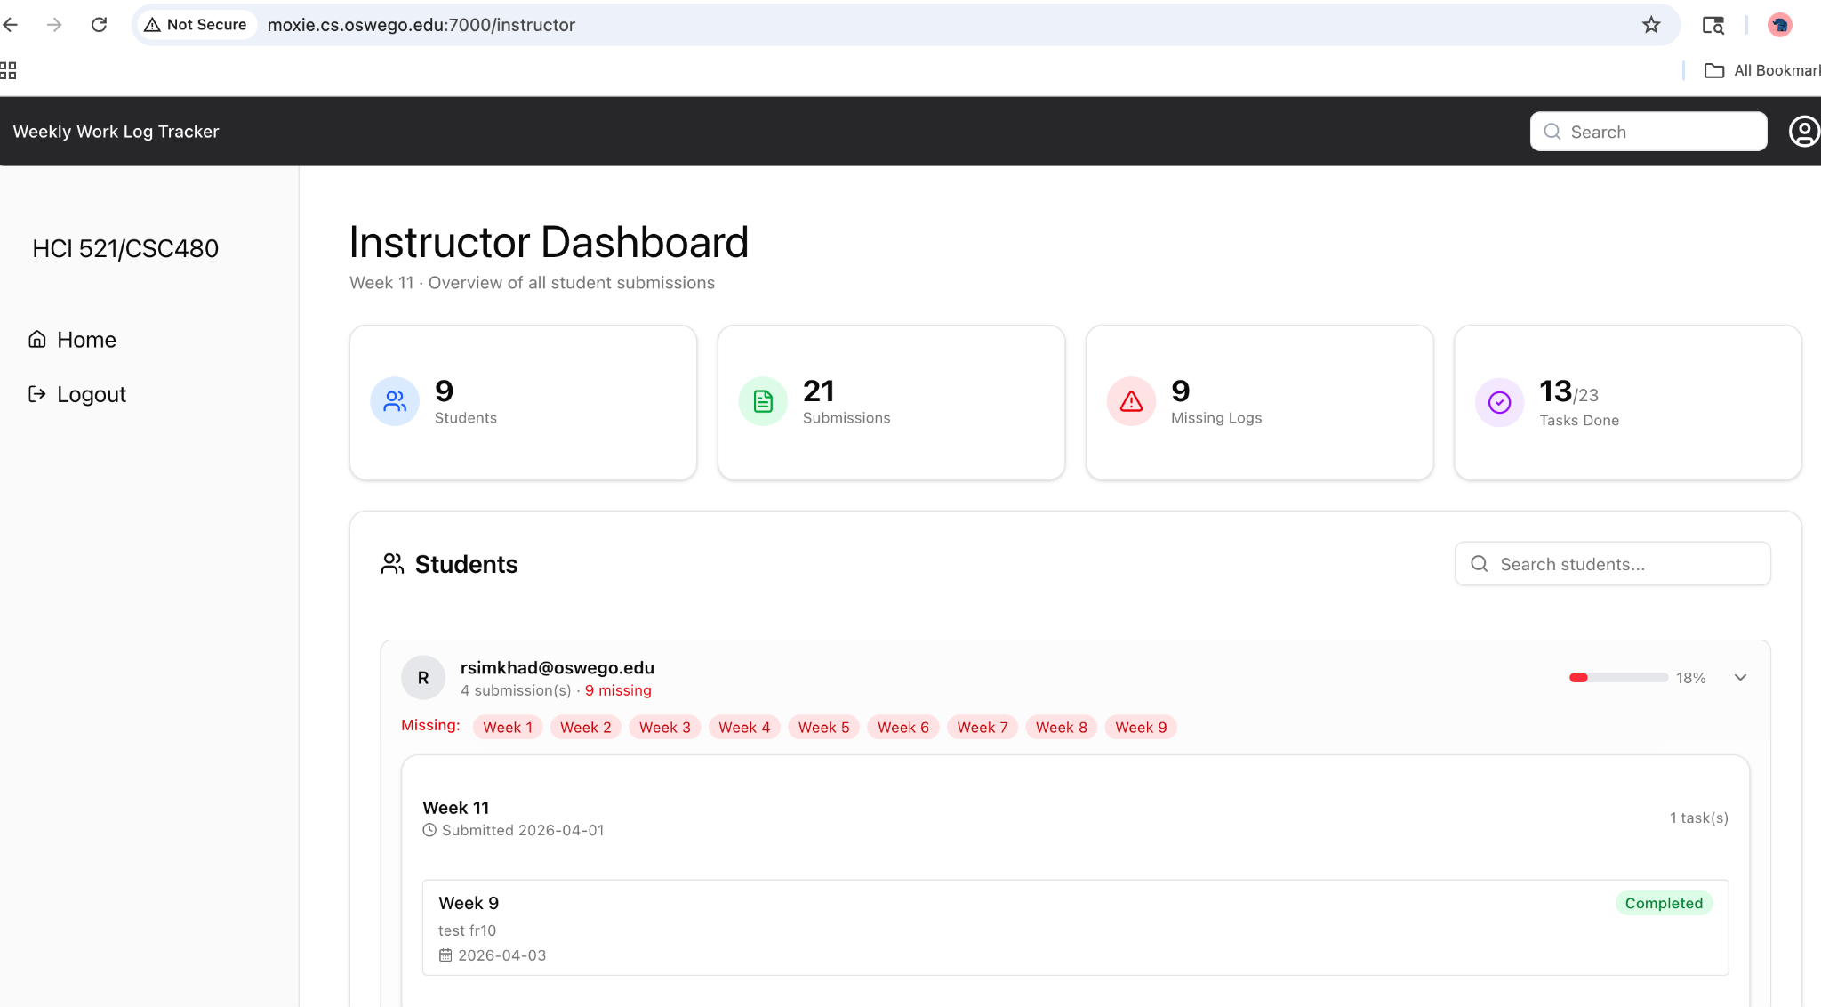
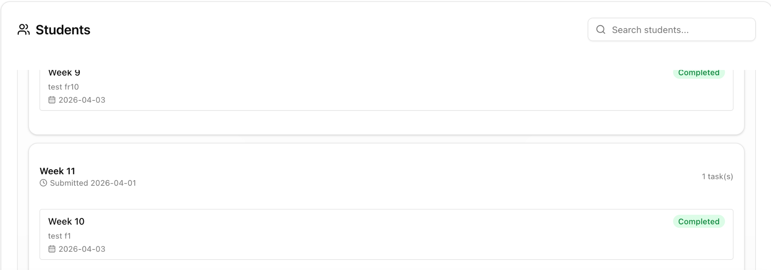
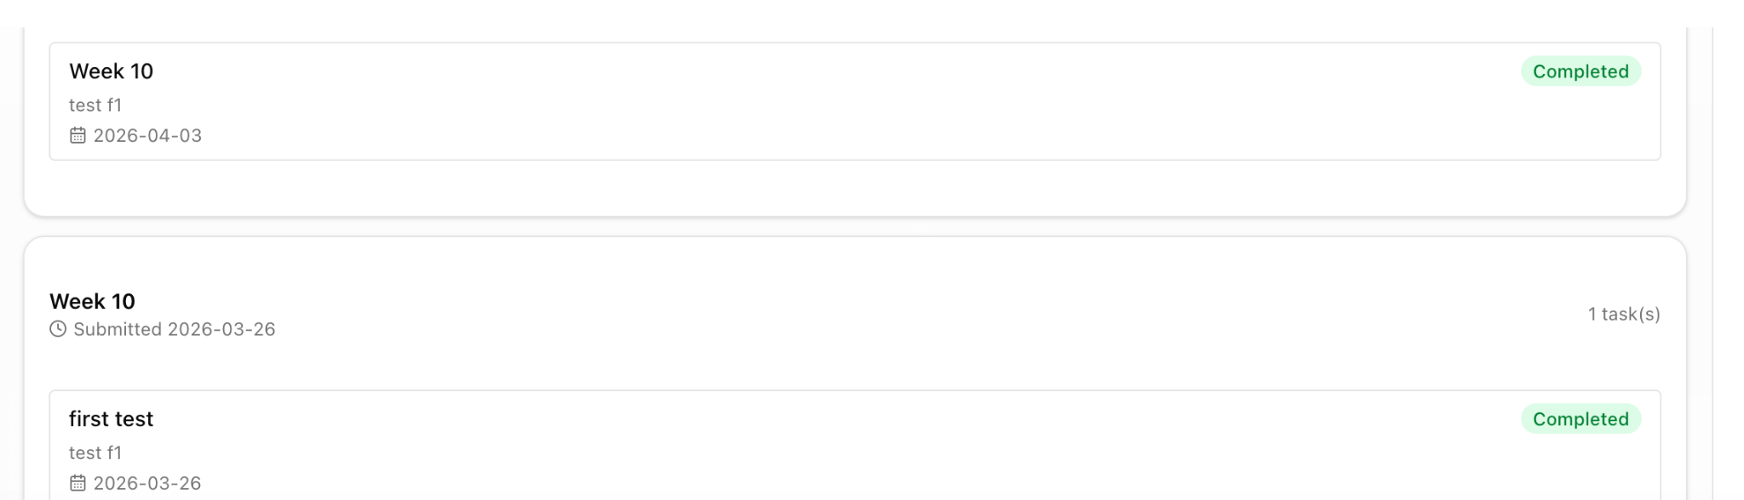

STP Test Case # ST-4
Requirement tested: FR-10.1
Description: The system shall preserve all previous worklog versions.
Build: v0.2.0_20260325
Determination: SUCCESSFUL

Setup:
- Open Chrome browser on Mac
- Navigate to Moxie server (http://moxie.cs.oswego.edu:7000/)
- Execute test

Execution:
As an instructor-
1. Ensure students have submitted multiple versions of a worklog.
2. Log in as an instructor.
3. Open the student’s worklog.
4. The instructor should see different versions submitted by the student.
Expected Result:
As an Instructor -
1. All previous versions are available to the instructor.
2. Each version contains the original submitted data.
3. New submissions do not overwrite older versions.

Actual Result:
As an instructor, multiple versions were visible, each submission appeared as a separate version, and older versions remained unchanged.
Screenshot: For instructor-



STP Test Case # ST-4
Requirement tested: FR-10.2 & 10.3
Description: The system shall allow instructors to view all submitted versions of a student’s worklog. The system shall retain worklog submissions for a minimum of five years(for this all previous versions of worklog).
Build: v0.2.0_20260325
Determination: SUCCESSFUL

Setup:
- Open Chrome browser on Mac
- Navigate to Moxie server (http://moxie.cs.oswego.edu:7000/)
- Execute test

Execution:
1. Log in as an instructor.
2. Navigate to a student’s worklog with multiple submissions.
3. View the version list / submission based on time.
Expected Result:
1. Different versions of the worklog should be present, and each version shall be clearly identified (e.g., version number, date/time).
2. Versions should be ordered logically (e.g., most recent first).
3. The instructor should be able to easily identify the latest submission.

Actual Result:
Different versions of the worklog were present, and each version was clearly identified with version details. The versions were ordered logically with the most recent submission displayed first. The instructor was able to easily identify the latest submission.
Screenshot:
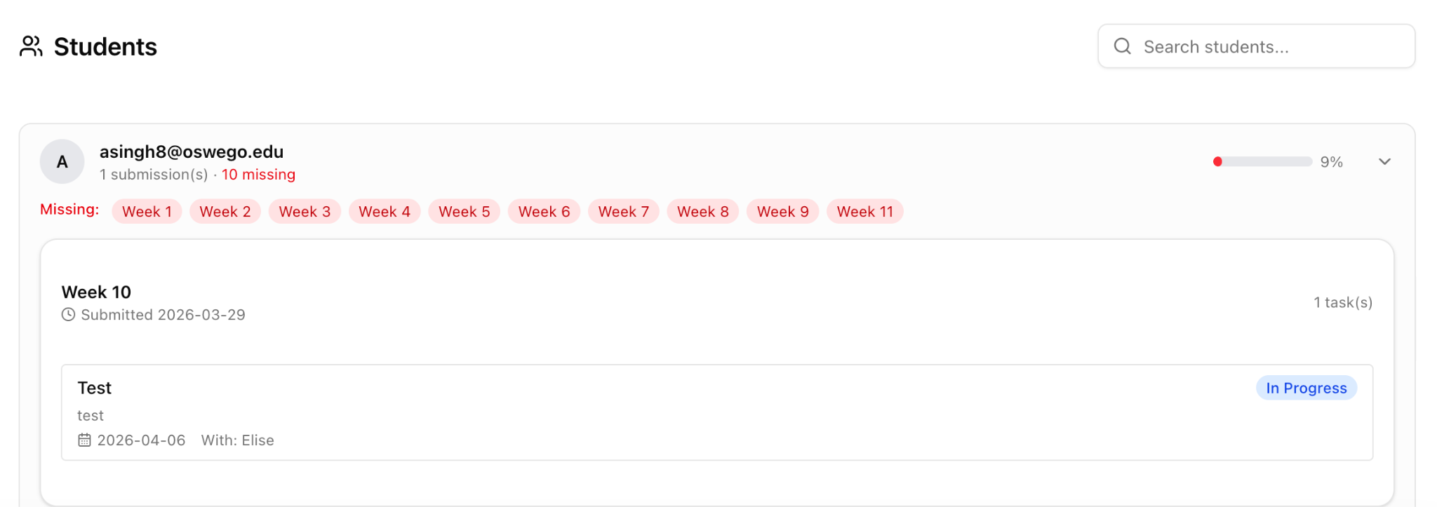
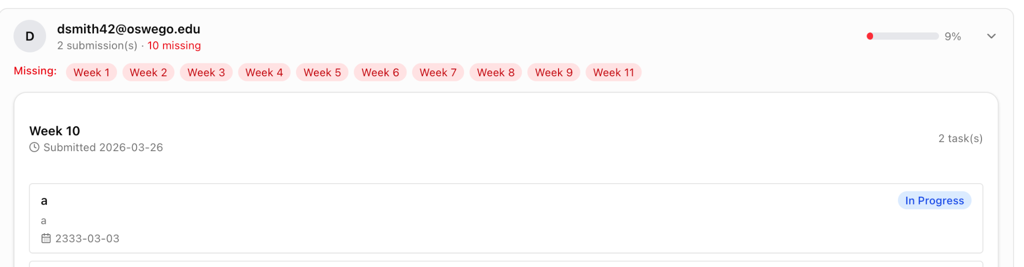
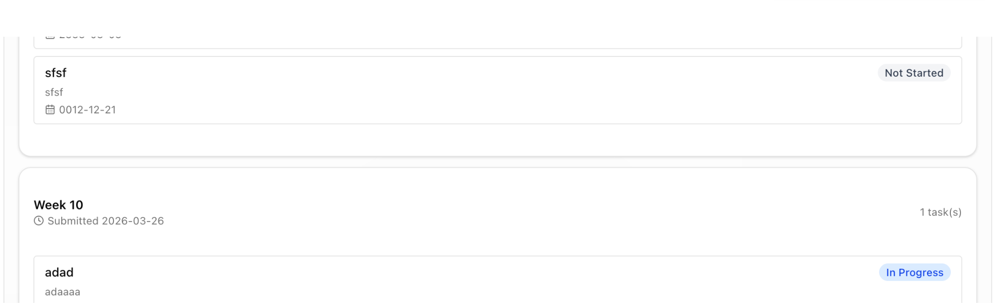

FR 12.1

STP Test Case # ST-4

Requirement tested: FR 12.1
Description: The system shall allow filtering of submissions by student name.
Build: v0.2.0_20260402
Determination: UNSUCCESSFUL

Setup:
- Open Chrome on Windows OS
- Navigate to front-facing Moxie server (http://moxie.cs.oswego.edu:7000/)
- Execute test

Execution:
- Log in with valid Instructor id
- Go to Home page
- Select search bar
- Type in student’s name to filter it
- View students submissions by name

Expected Result:
Student shows up when searching their name
What to expect : Student name and their submissions

Actual Result:
No filter for the name of students, just a search bar; students are kept by email instead of name so you must search their email instead.

Screenshot:
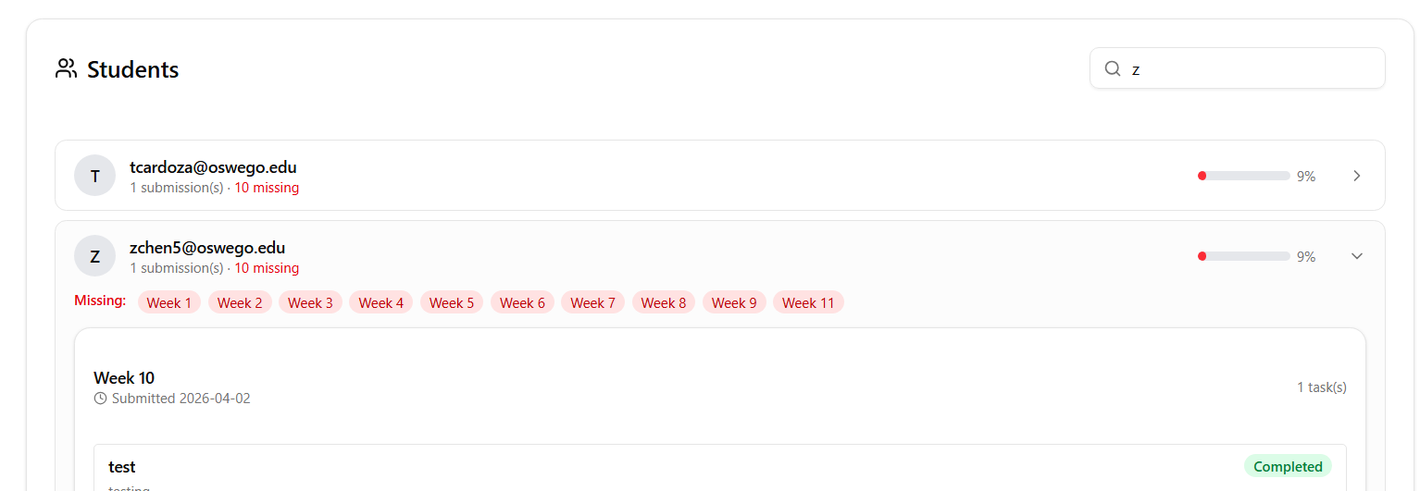

Bug Found :
The students are shown by their email instead of name/ or if this is intended there is no button to change it to filter it by name as seen in the picture above

FR 13
STP Test Case # ST-4
Requirement tested: FR-13
Description: The system shall represent task completion using a checkbox input.
Build: v0.2.0_20260325
Determination: SUCCESSFUL

Setup:
- Open Chrome browser on MacOS
- Navigate to front-facing Moxie server (http://moxie.cs.oswego.edu:7000/)
- Execute test

Execution:
- Opened the moxie server
- Clicked “continue this weeks worklog”
- Filled out worklog and pressed complete
- Checked the notification center for the green check mark

Expected Results:
The system shall indicate task completion by displaying a checkbox.

Actual Results:
A green completion check is shown on the notification page next to a completed worklog.
Screenshots: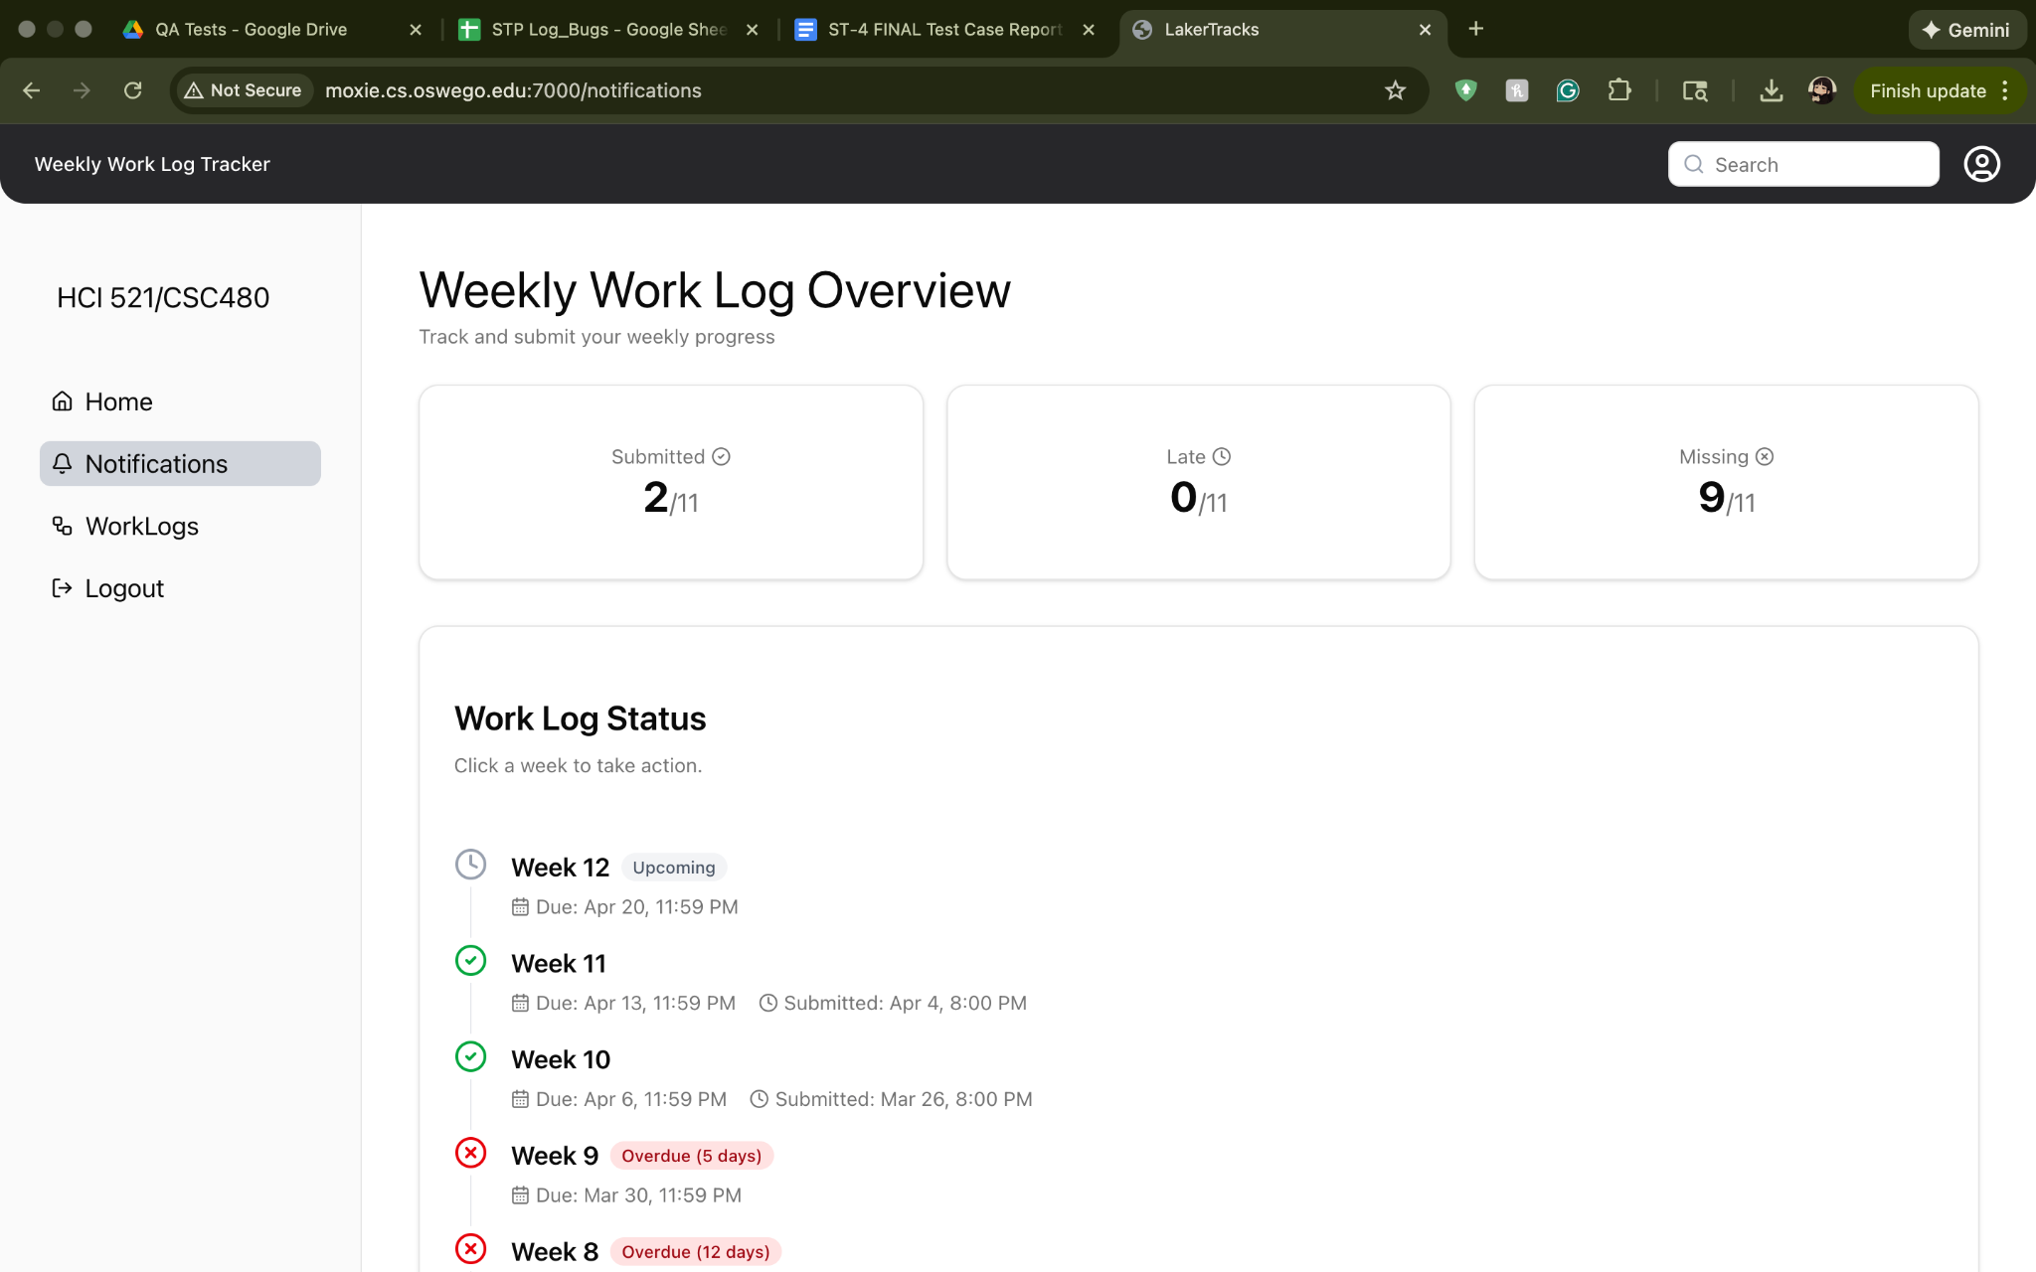

ST-4 BUGS

Bug/Defect # ST-4_Defect - 1

Severity: Medium

STP Test Case: # ST-4
Requirement Tested - FR 1.3
Build/Release #v0.2.0_20260325

Steps during test:
- Open Safari browser on Mac OS
- Navigate to Homepage on Moxie website
- Clicked on Continue this week’s worklog button
- Fill in the details and submit the worklog

Description:
The most recent worklog submission notification (week 11 ) was not on the top of the notification center. Instead it showed the previous submission (week 10) notification on top always.

Potential Cause (if known):
Not sure, the old notification seems to be static on top.
Screenshots of error:

Bug/Defect # ST-4_Defect - 2

Severity: High

STP Test Case: # ST-4
Requirement Tested - Addition bug found while testing FR 1.3
Build/Release #v0.2.0_20260325

Steps during test:
- Open Safari browser on Mac OS
- Navigate to Homepage on Moxie website
- Click on Continue this week’s worklog button
- Fill in the task name

Description:
The heading ‘Task 1’ got replaced with the task 1 name inputted by the user.

Potential Cause (if known):
Task name and heading task 1 is interconnected somehow?

Screenshots of error:

Bug/Defect # ST-4_Defect - 3

Severity: Medium

STP Test Case: # ST-4
Requirement Tested - Addition bug found while testing FR 2.5
Build/Release #v0.2.0_20260325

Steps during test:
- Open Google Chrome browser on Mac OS
- Navigate to Homepage on Moxie website
- Log in as instructor
- Right click and choose “inspect”
- Go to the Network Section
- At API right click and choose “block it”

Description:
The system should send an error message as they can’t load anything from the database, instead it just should that there are no submissions.

Screenshots of error:


Bug/Defect # ST-4_Defect - 4
Severity: High
STP Test Case: # ST-4
Requirement Tested - For FR-6, fails to display an appropriate error message when homepage data retrieval (API call) fails.
Build/Release #v0.2.0_20260325
Description
The system fails to display an appropriate error message when homepage data retrieval (API call) fails. Instead, it shows misleading information to the user.

Steps during test:
Open Chrome browser on Mac.
Navigate to: http://moxie.cs.oswego.edu:7000/
Log in as a student.
Right click → Inspect.
Go to the Network tab.
Refresh the page once to load API calls.
Locate the API request (fetch/XHR).
Right-click the request → Click Block request URL.
Refresh the page again.
Observe the homepage behavior.

Description(Expected vs Actual):
Expected: The system should display a clear error message indicating that homepage data could not be retrieved due to an API failure.
Actual: The system displays “No worklog submitted yet”, even though a worklog exists, instead of showing an error message.
Screenshot:
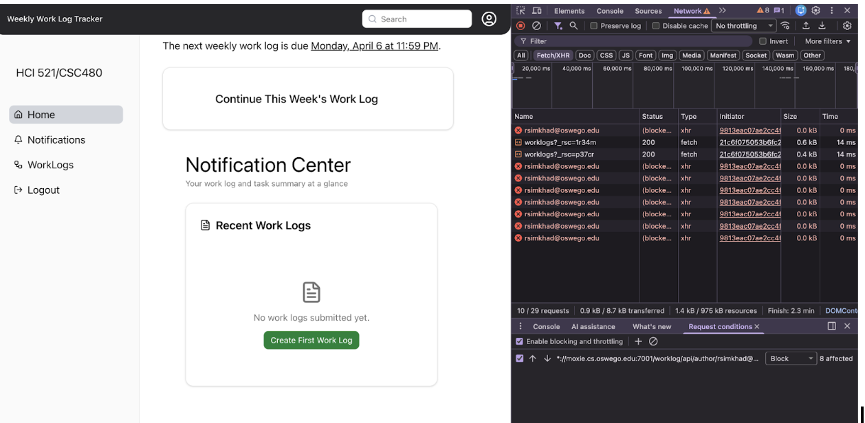

Regression Test Results
FR - 5.4 (PASSED)
FR - 6.2 (PASSED)
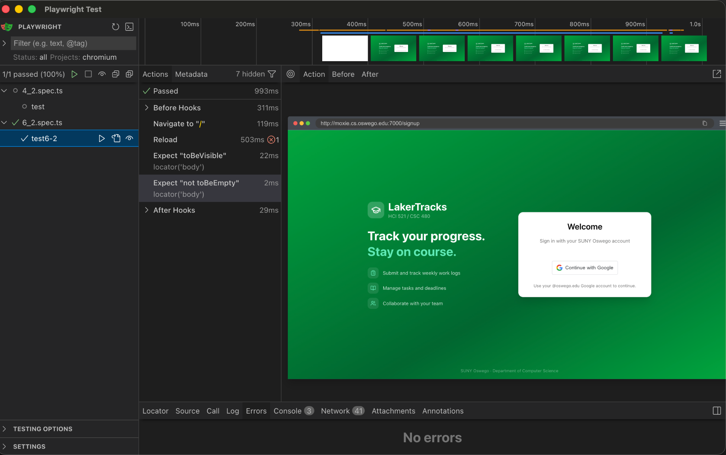

FR - 6.3 (PASSED)
